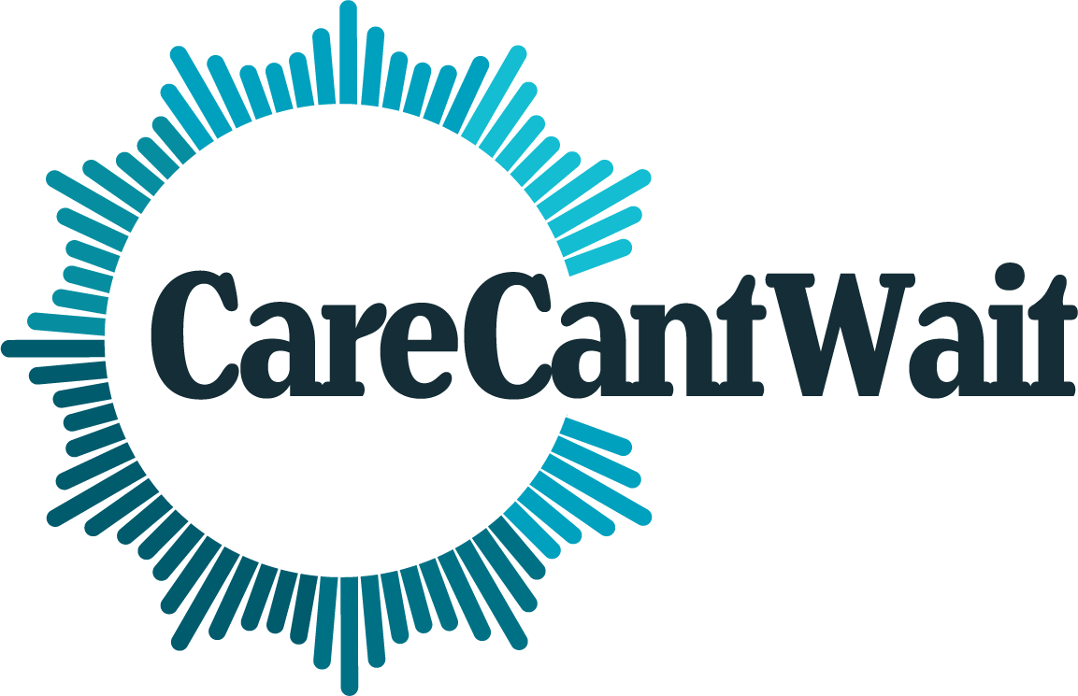

January 27th, 2025
The Honorable John Thune The Honorable Chuck Schumer
Majority Leader Minority Leader
U.S. Senate U.S. Senate
Washington, DC 20515 Washington, DC 20515
The Honorable Mike Johnson The Honorable Hakeem Jeffries
Speaker Minority Leader
U.S. House of Representatives U.S. House of Representatives
Washington, DC 20515 Washington, DC 20515 Dear Leaders Thune and Schumer, Speaker Johnson, and Leader Jeffries,
The expiration of the temporary provisions of the Tax Cuts and Jobs Act in 2025 presents a stark choice for lawmakers: continue to spend billions of taxpayer dollars on tax cuts for the wealthy and large corporations, or lower costs for families and spur economic growth by raising revenue to invest in programs that help workers and families. One of the most significant ways lawmakers can help workers and families is by investing in programs that support the caregiving work that every family, community, and our entire economy relies on.

All of us will care for someone, or need care for ourselves, at some point in our lives. Care is one of the highest and fastest-growing costs for families. Child care is the second-largest expense for many families in the U.S., and in many metropolitan areas, costs more than rent for a
two-bedroom apartment. For families caring for aging or disabled relatives, the median monthly cost of full-time in-home care or an assisted living facility is upwards of $5,000 per month. And the lack of paid leave pushes many caregivers out of the labor force, putting a strain on families’ finances, time, and mental health. A national paid family and medical leave program would put
$8,700 back into the pocket of a typical worker who needs 12 weeks of leave to care for themselves or their family. The high cost of care not only makes it harder for families to make ends meet, but makes it harder for them to save for the future. Millions of families are struggling unnecessarily with the high cost of care, even as the care workforce remains underpaid and undervalued.

The high cost of care borne by families is only one aspect of the care crisis. Many areas of the country, rural and urban alike, lack enough care options to provide families with meaningful choices. The care workforce is one of the lowest-paid sectors – such that many cannot support their own families on their poverty-level wages alone. The underinvestment in the care workforce leads to high rates of turnover, contributes to worker shortages, and also increases training costs for employers. Care is the quintessential “broken market,” meaning that the only way to resolve the care crisis is through systemic and sustained public investment. Care should be funded like a public good and relies on a strong, stable workforce.
Prioritizing public investments in care is not only an urgent need for families, but also for the broader economy. Robust spending on care supports (including comprehensive paid family and medical leave, child care, and aging and disability care) could increase economic output by $775 billion per year as a result of increased labor force participation by women. It would also create millions of jobs and support employers by providing a more stable workforce. In contrast, extending the 2017 tax cuts for the wealthiest would shrink the economy and explode the deficit, harming families.

To meaningfully lower costs for families, we urge you to reject tax giveaways to the wealthiest individuals and largest corporations, and prioritize investments in care. Specifically, we urge you to:
- Reject cuts to critical programs that families rely on. Programs like Medicaid or the Supplemental Nutrition Assistance Program (SNAP) help families afford health care, food, and other basic needs. We urge you to reject any and all cuts to these and other critical programs.
- Raise revenue. In order to support the care investments of the kind and at the scale families and our economy need, lawmakers must raise significant revenue by making sure those at the top pay their fair share. Some estimates have found that
President-elect Trump’s tax proposals would increase the debt by almost $8 trillion over a 10 year-period. Rather than squander public dollars on more tax cuts for billionaires, we urge you to allow the expiring provisions of the Tax Cuts and Jobs Act for households with incomes above $400,000 to sunset, and reject new tax proposals that overwhelmingly benefit the wealthiest.
- Make direct investments in care infrastructure through the tax bill. For example, the Senate Finance Committee and House Ways & Means Committee have jurisdiction over mandatory child care money and could increase funding for the Child Care Entitlement for States (CCES). This would provide states with more resources to both lower costs for families and build the supply of care.

- Understand that tax credits for families needing care are not a substitute for care investments - families need both. Expanding some tax policies can help mitigate the cost of care, particularly the expansions that are targeted at families with the lowest incomes - such as increasing the refundability of the Child and Dependent Care Tax Credit (CDCTC) and the Child Tax Credit (CTC), or increasing the size and availability of the Earned Income Tax Credit (EITC) for workers with very low incomes who do not claim children on their tax return. But even if improved, these credits are an incomplete solution to the care crisis: they are insufficient to fully meet families’ care costs, do not help increase the supply of care, are poorly targeted to providers, and are insufficient to ensure that the underpaid workforce can support themselves and their families with dignity.
- Reject proposals that do not meaningfully address the cost of care or build supply of care. Some tax benefits are not worth improving, especially when doing so would forego revenue that could have been allocated towards meaningful care benefits. These include:
  - Expanding Dependent Care Assistance Plans (DCAPs). DCAPs are voluntary benefits that employers can offer, and provide tax savings for employees who can afford to put money aside from their paychecks that they can use for child and dependent care expenses throughout the year. While many higher-paid workers take advantage of this program, DCAPs really are not helpful for many of the families who struggle the most with the cost of care – and proposals to expand DCAPs mostly focus on increasing how much employees can contribute, which only benefits higher paid workers but does nothing to help struggling families.
  - Increasing the size of tax credits for employers who offer child care or paid leave benefits under sections 45F and 45S of the tax code. These credits have been proven ineffective and a waste of tax dollars. The 45F child care tax credits have been claimed by larger corporations, have not demonstrably increased the availability of care, and support corporate child care chains rather than investing in the diversity of supply that families need and want. The 45S paid leave tax credits are also nearly exclusively claimed by larger corporations, do not provide enough of an incentive to expand access to employer-provided paid leave, and do nothing to help small businesses. We urge you to focus on policy solutions that would meaningfully impact the supply, diversity of care options, and cost of care for families.
Unfortunately, for decades, our nation has failed to support public investments in care, resulting in too many families, older adults, and disabled people struggling to access and afford care that meets their needs. Women and people of color disproportionately shoulder unpaid caregiving

responsibilities, often at the expense of their own economic security, and make up the vast majority of the underpaid and undervalued care workforce.
The decisions you make during the 2025 tax debate will mean the difference between lowering the cost of care for families, and worsening their struggles to make ends meet by making them – and future generations – pay for even more tax cuts for billionaires. We urge you to reject enacting any more tax cuts for the wealthiest and big corporations during the 2025 tax fight, and instead to invest in care and lower costs for families.
If you have any questions, please contact Jaimie Worker (jaimie@caringacross.org) or Amy Matsui (amatsui@nwlc.org).
Sincerely,
A Better Balance Accountable US Access Ready Inc. AFL-CIO
AFSCME
AgeGuide Northeastern IL Alianza Americas
Alliance for Quality Education Allies for Independence
American Association of People with Disabilities (AAPD) American Association of University Women
American Friends Service Committee American Muslim Health Professionals Americans for Tax Fairness (ATF) Arizona Center for Empowerment Articulations Consulting
Asset Building Strategies
Association of People Supporting Employment First Association of University Centers on Disabilities Autistic Women & Nonbinary Network
Bell Policy Center
Black Californians United for ECE Black Voters Matter Fund
Boone County Council on Aging California Alliance for Retired Americans Care in Action
Caring Across Generations
Center for Economic and Policy Research Center for Law and Social Policy (CLASP)

Center for WorkLife Law
Child Care for Every Family Network Child Care Law Center
Children’s Council of San Francisco Coalition on Human Needs Colorado Fiscal Institute
Common Good Iowa Community Catalyst Community Change Action Cupit's Angel Wings
DC Action
Detroit Disability Power Disability Belongs
Disability Rights Education and Defense Fund Diverse Elders Coalition
Economic Opportunity Institute Epilepsy Foundation of America Equal Rights Advocates
Excessive Wealth Disorder Institute Fair Share America
Family Forward Family Values @ Work
Family Values @ Work Action Feminist Majority
Futures Without Violence Girls for Gender Equity
Hand in Hand: The Domestic Employers Network Hawaii Children's Action Network Speaks!
Health Care Voices Housing Action Illinois
Indiana Community Action Poverty Institute Indivisible
Indivisible Marin
Illinois Alliance for Retired Americans Institute for Policy Studies, Poverty Project Institute for Women's Policy Research Institute on Taxation and Economic Policy ISAIAH Minnesota
Jewish Women International Jumpstart for Young Children Just Solutions
Justice + Joy National Collaborative Justice in Aging
Kindred Futures

Main Street Alliance
Maine Center for Economic Policy Maine People’s Alliance
Maine Women's Lobby Make the Road Nevada
Maui Economic Opportunity, Inc. Michigan’s Children
Michigan League for Public Policy Missouri Jobs with Justice MomsRising
MoveOn
Multicultural Child Family Center National Association for Family Child Care
National Association of Councils on Developmental Disabilities National Association of Social Workers (NASW)
National Coalition for the Homeless National Council of Jewish Women National Disability Rights Network (NDRN) National Domestic Workers Alliance National Employment Law Project National Health Law Program
National Organization for Women
National Partnership for Women & Families National Resource Center on Domestic Violence National Women’s Law Center
National Women's Political Caucus New Day Nevada
New Mexico Asian Family Center NBJC
NETWORK Lobby for Catholic Social Justice New Jersey Citizen Action
New Jersey Time to Care Coalition Oakland Forward Action Fund Ohio Organizing Collaborative
Organizers of Land Enrichment New Mexico Our Revolution
Oxfam America Paid Leave for All
Parent Voices California PHI
Physicians for Reproductive Health Poder Latinx
Prevent Child Abuse New York Progressive Leadership Alliance of Nevada

Public Advocacy for Kids (PAK) RootsAction.org
Service Employees International Union (SEIU) State Revenue Alliance
Start Early Funders Coalition Supermajority
Take On Wall Street The Arc Michigan
The Arc of the United States The Kelsey
The National Domestic Violence Hotline
The Restaurant Opportunities Center of Pennsylvania (ROC PA) The Restaurant Opportunities Centers United
Thrive Alabama UDW.AFSCME Local 3930
Ujima UnidosUS
United Church of Christ Virginia Organizing
Voices of Health Care Action Voices for Progress
We Vote. We Win.
Well Spouse Association
Western New York Child Care Action Team Women Employed
Zero to Five Montana

