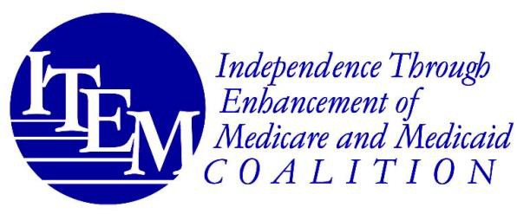

November 19, 2024

The Honorable Mariannette Miller-Meeks Chairwoman
Subcommittee on Health, Committee on Veterans Affairs
U.S. House of Representatives
1034 Longworth House Office Building Washington, DC 20515

Re: ITEM Coalition Support for H.R. 9478, the Veterans SPORT Act

Dear Chairwoman Miller-Meeks:

The undersigned members of the Independence Through Enhancement of Medicare and Medicaid (ITEM) Coalition write to express our support for H.R. 9478, the Veterans Supporting Prosthetics Opportunities and Recreational Therapy (“SPORT”) Act, which would provide coverage under the Department of Veterans Affairs (“VA”) benefit for prosthetic limbs that veterans with limb loss use to participate in sports and other recreational activities in order to remain fit, healthy, and engaged in physical activities of their choice. Specifically, this bill would recognize prosthetic devices for sports and recreational use as medically necessary under the VA benefit which the ITEM Coalition fully supports. As its title suggests, access to activity- specific prostheses would entail access to the recreational therapy veterans may need to perform these activities safely.

The ITEM Coalition is a national consumer- and clinician-led coalition advocating for access to and coverage of assistive devices, technologies, and related services for people with injuries, illnesses, disabilities, and chronic conditions of all ages. Our members represent individuals with a wide range of disabling conditions, as well as the providers who serve them, including spinal cord injury, brain injury, stroke, limb loss, multiple sclerosis, paralysis, cerebral palsy, spina bifida, hearing, speech, and visual impairments, and other life-altering conditions.

Ensuring equitable access to prostheses, orthoses, and other adaptive equipment utilized by individuals with disabilities for the performance of physical activities has been a long-time priority of the ITEM Coalition. Veterans with limb loss and limb difference continue to face insurmountable barriers to equal participation in physical activities in order to remain fit and healthy, which is why this bill is so important. VA health plans—as well as federal, state, and private plans—have historically and routinely denied access to prosthetic and orthotic care for physical activities as “not medically necessary.” Far too often, the medical necessity standard has been interpreted too narrowly for individuals with limb loss, allowing coverage for prostheses for the purposes of simple ambulation from point A to point B, or for dexterity of the upper extremities.

1250 Connecticut Ave. NW, 8th Floor • Washington, DC 20036 • www.itemcoalition.org •
202-466-6550

Without health plan coverage, VA enrollees and families are forced to incur prohibitive out-of- pocket costs for activity specific prostheses, risk harm or injury using a prosthesis not designed for physical activity, or—without access to activity-specific prostheses—live sedentary lifestyles with costly health complications, including obesity and diabetes. Veterans with disabilities need access to specialized prostheses to be able to participate equitably in physical activity, just like their non-disabled peers.

H.R. 9478 is squarely in line with the goals of the ITEM Coalition to ensure that all people, particularly veterans who have already sacrificed so much, are able to access the specialized devices and services they need to ensure their health and independent function. For these reasons, we are proud to support this critically important legislation and look forward to working with your office to ensure its enactment into law.

************

If you have any questions, please do not hesitate to contact ITEM Coalition co-coordinators Peter Thomas and Michael Barnett at Peter.Thomas@PowersLaw.com or Michael.Barnett@PowersLaw.com or call 202-466-6550.

Sincerely,

The Undersigned Members of the ITEM Coalition

Access Ready, Inc. ACCSES
Alexander Graham Bell Association for the Deaf and Hard of Hearing All Wheels Up
American Association of People with Disabilities American Association on Health and Disability American Congress of Rehabilitation Medicine American Council of the Blind
American Music Therapy Association American Physical Therapy Association American Therapeutic Recreation Association Amputee Coalition*
Association of Rehabilitation Nurses Autistic Women & Nonbinary Network Blinded Veterans Association
Center on Aging and DIS-Ability Policy Christopher & Dana Reeve Foundation* Institute for Matching Person and Technology Lakeshore Foundation
Long Island Center for Independent Living, Inc. (LICIL)
National Association for the Advancement of Orthotics and Prosthetics National Association of Councils on Developmental Disabilities National Disability Rights Network (NDRN)

RESNA
Rifton Equipment The Viscardi Center United Cerebral Palsy
United Spinal Association*

*ITEM Coalition Steering Committee Member

