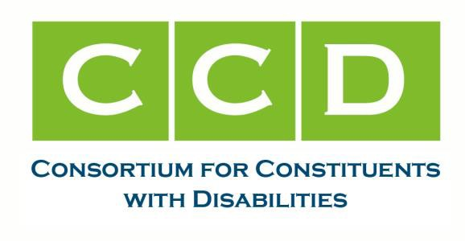
July 24, 2024

Senator Maria Cantwell, Chair
Senate Commerce, Science and Transportation Committee 254 Russell Senate Office Building
Washington D.C. 20510 Dear Chair Cantwell:
The Consortium of Constituents with Disabilities (CCD) Transportation Task Force urges the Senate Committee on Commerce, Science and Transportation to move forward with a confirmation hearing for the appointment of the disability advocate for the Amtrak Board of Directors. CCD is the largest coalition of national organizations working together to advocate for federal public policy that ensures the self-determination, independence, empowerment, integration and inclusion of children and adults with disabilities in all aspects of society. It is critical that the Amtrak Board have this important voice for the disability community as quickly as possible. The disability community has anxiously waited for the position to be filled since it was first proposed in legislation by Senator Duckworth multiple years ago.
Passengers with disabilities have experienced accessibility barriers to Amtrak for decades. Despite the requirements of the Americans with Disabilities Act (ADA) which was passed in 1990, Amtrak continues to struggle in ensuring that its stations and trains are accessible for travelers with disabilities. At the twenty year anniversary of the ADA, the National Disability Rights Network (NDRN) and P&A agencies performed surveys of a number of stations and published a haunting report on such access barriers. The report ended up being the catalyst for an investigation and eventual settlement agreement between Amtrak and the U.S. Department of Justice (DOJ) to improve accessibility. Congress has appropriated millions of dollars in funds to Amtrak in recent years to implement the agreement.

While this Board position is vacant, Amtrak has moved forward with options for future trainset that we do not believe will fully meet the needs for riders with disabilities. Amtrak has adopted new train designs that will roll out in the coming years, that despite the advocacy from disability organizations through written letters and oral comments at regularly scheduled meetings, will be built with narrow aisles that will not be accessible for riders who use mobility devices. Despite demonstrated examples that show that a wider aisle design is feasible and possible, Amtrak has refused to implement a new design. Past Amtrak trainsets have remained on the tracks for up to fifty years. Inaccessible trainsets will be used for many decades, greatly delaying accessibility for generations to come.

820 First Street, NE Suite 740 • Washington, DC 20002 • PH 202-567-3516 • FAX 202-408-9520 • Info@c-c-d.org • www.c-c-d.org
660

The Bipartisan Infrastructure Law that passed in the 117th Congress included a provision that required a disability advocate on the Amtrak Board of Directors. Soon after its enactment, a candidate was nominated for this position. However, the nomination failed to move forward during the 117th Congress and is still vacant.
The impact of the accessibility barriers for people with disabilities, which are still not being fully addressed in the development and rollout of Amtrak’s new trainsets, highlights the imperative need to expeditiously fill this position. Despite these accessibility barriers and the legislation mandate, Senate confirmation hearings for a disability advocate have not occurred. We urge the Commerce Committee to swiftly fill this position so this advocate can further raise the importance of Amtrak being accessible for all.

Thank you for your time and attention to this urgent issue. If you have any questions, please reach out to Claire Stanley, Director of Advocacy and Governmental Affairs with the American Council of the Blind at cstanley@acb.org.
Sincerely,
Access Ready Inc.
American Council of the Blind Autistic Self Advocacy Network
Disability Rights Education and Defense Fund (DREDF) Epilepsy Foundation
National Association of Councils on Developmental Disabilities Paralyzed Veterans of America
RespectAbility
United Spinal Association

2

