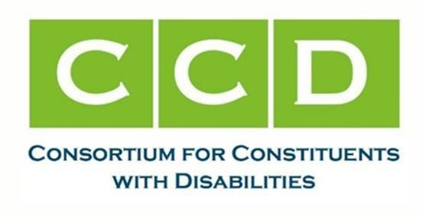

July 16, 2024

The Honorable Mike Johnson Speaker of the House  U.S. House of Representatives Washington, D.C. 20515 | The Honorable Hakeem Jefferies Minority Leader  U.S. House of Representatives Washington, D.C. 20515
The Honorable Steve Scalise Majority Leader  U.S. House of Representatives  Washington, D.C. 20515 | The Honorable Katherine Clark Minority Whip  U.S. House of Representatives  Washington, D.C. 0515

Dear Speaker Johnson, Majority Leader Scalise, and Minority Leader Jeffries,
The undersigned Members of the CCD Autism, Developmental Disabilities, and Family Support Task Force write in strong support of the Autism CARES Act of 2024 (H.R. 7213), led by Representative Chris Smith and Representative Henry Cuellar urge you to support its swift passage in the House of Representatives under suspension of the rules. This bill builds on years of progress that has been made through previous versions of the Autism CARES Act and will help move forward critical research and training programs that will benefit the estimated 1 in 36 autistic children and 1 in 45 autistic adults in the United States.
The Autism CARES Act has been the single most important piece of legislation to invest funding in and coordinate programs in autism research and training programs in the U.S. Department of Health and Human Services, since first passing in 2006. It has led to improvements in early intervention services, a better understanding of the prevalence of autism, and a better understanding of the co-occurring health conditions that autistic people experience.
Importantly, it has also been responsible for thousands of future health professionals being trained on how to screen, diagnose, and provide interventions to autistic people and other individuals with neurodevelopmental disabilities to improve their health and wellbeing. Thanks to the Autism CARES Act, many health professionals are better equipped to meet the ever-changing and diverse needs of autistic people and other people with neurodevelopmental disabilities.
Now more than ever, reauthorizing this law is critical. As far as we’ve come in terms of our understanding of autism and acceptance of autistic people – there’s so much work to do to ensure that every autistic person can access personalized health care and services and supports that meet their needs. Significant gaps in access to these services persist. The additional research and

training to address those gaps through the investments and improvements made by the Autism CARES Act of 2024 are vital to continuing progress and closing gaps.
As the current version of the CARES Act expires on September 30, 2024, we urge you to lend your support to pass this incredibly important piece of legislation under suspension of the rules. The undersigned major national organizations representing millions of individuals with developmental and other disabilities, families, providers, researchers, and professionals, urge Congress to act quickly to reauthorize this critical law.
Sincerely,
Undersigned members of the CCD Autism, DD, and Family Support Task Force:
Access Ready, Inc.
Allies for Independence
American Academy of Pediatrics
American Association on Intellectual and Developmental Disabilities American Music Therapy Association
Association of University Centers on Disabilities Autistic Self-Advocacy Network
Autistic Women and Nonbinary Network Autism Society of America
Autism Speaks CommunicationFIRST Communication 4 ALL
National Disability Rights Network National Down Syndrome Congress National Down Syndrome Society National Respite Coalition
National Association of Councils on Developmental Disabilities The Arc of the United States
Tourette Association of America
United States International Council on Disabilities United Spinal Association

