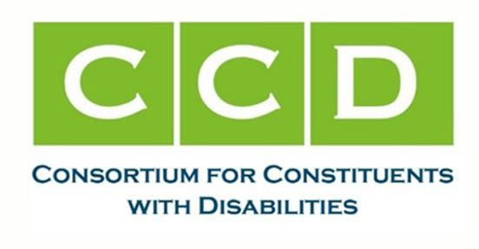

May 6, 2024

The Honorable Tammy Baldwin Chair
Labor, Health and Human Services, Education, and Related Agencies Appropriations Subcommittee
135 Dirksen Senator Office Building Washington, DC 20510
The Honorable Shelley Moore Capito Ranking Member
Labor, Health and Human Services, Education, and Related Agencies Appropriations Subcommittee
156 Dirksen Senate Office Building Washington, DC 20510

Dear Chair Baldwin and Ranking Member Moore Capito:

On behalf of the Consortium for Constituents with Disabilities Technology and Telecommunications Task Force, the undersigned organizations are writing to ask for your support for the inclusion of $42 million in the Fiscal Year (FY) 2025 Senate Labor, Health and Human Services and Education Appropriations (LHHS) bill for the Assistive Technology (AT) Act Programs. Further, we respectfully request instructions be included to eliminate the following language from the Labor, Health, and Human Services Appropriations Act (AT Act) that states “provide $2,000,000 for competitive grants to support existing and new alternative financing programs that provide for the purchase of AT devices.” With this change, we further request that the available $2 million be allocated directly to the AT Act (which contributes to the increased total requested of $42 million).

Funding provided through the AT Act supports programs that ensure people with disabilities have access to and are able to acquire the assistive technology, devices, and services they need to live, work, and attend school in their communities.

The Consortium for Constituents with Disabilities is a coalition of more than 100 national disability organizations working together to advocate for national public policy that ensures the self- determination, independence, empowerment, integration and inclusion of children and adults with disabilities in all aspects of society. The Technology and Telecommunications Task Force focuses on national policy regarding matters of telecommunications and technology, including assistive technology, in order to help move society toward our ultimate goal of full inclusion for all people with a disability.

The AT Act programs provide critical funding to ensure people with disabilities can access and acquire the assistive technology devices and services they need to live, work, and attend school in their communities. Funding the AT Act at $42 million would allow programs to increase the breadth of services required by the law and address the consistently increased demand for these direct services.

Section 4 State AT Act Grantees receive a formula grant in all 50 states, 5 U.S. territories, and the District of Columbia under the Assistive Technology (AT) Act of 2004. These 56 grantees are required to carry out a continuum of specified state level and state leadership activities that increase the access to and acquisition of assistive technology, including state financing activities (such as financial loans, cooperative buy, funds of last resort, etc.), device reutilization (including recycling, repair, refurbishment and device exchange), device loan/borrowing and device demonstration services. These services are available for persons with all types of disabilities, all ages, in all environments (education, employment, community living and information technology). While families and guardians are the primary beneficiaries of services for individuals with disabilities, AT Act programs provide a wide range of services and supports to other targeted individuals such as educators, employers, health care providers, rehabilitation providers, and technology experts, including web designers, procurement officials and AT manufacturers and vendors. While the 2022 reauthorization maintained the key components of the direct services program, the most important part of the reauthorization was to increase the capacity of AT Act Programs. In order to fulfill this intent, the reauthorization needs to be met with increased resources to achieve the intent of the reauthorization.
The nationwide network of Protection and Advocacy for Assistive Technology (PAAT) programs in every state, the District of Columbia, five territories, and a fifty-seventh agency serving the Hopi, Navaho, and San Juan Southern Paiute tribes in the Four Corners region has been similarly under- funded. Twenty-four programs receive a minimum allotment of just $50,000 and all the territories receive $30,000. Larger states such as Florida ($293,971), Georgia ($145,757), Ohio ($158,990), and Pennsylvania ($174,971) receive insufficient funding when compared to their populations. The PAAT programs use these very limited funds to provide needed advocacy services to children and adults with disabilities. Every PAAT program conducts trainings and works with families, medical providers, schools, employers, and communities to ensure that individuals have access to the assistive technology they need.

Thank you again for your efforts on behalf of the AT Act, which is so important to Americans with disabilities. We look forward to working with you in the coming months as Congress starts the FY 2025 appropriations process. If you have any questions, please feel free to contact one of the CCD Technology and Telecommunications Task Force Co-Chairs: Audrey Busch, audrey.busch@ataporg.org; Sarah Malaier, smalaier@afb.org; Eric Buehlmann, eric.buehlmann@ndrn.org; or Laura Kaloi, lkaloi@stridepolicy.com.

Sincerely,

Association of Assistive Technology Act Programs National Disability Rights Network (NDRN)
Association of People Supporting Employment First (APSE) Autism Society of America
The Advocacy Institute
United States International Council on Disabilities Access Ready Inc.
Perkins School for the Blind American Council of the Blind Council for Exceptional Children Council for Learning Disabilities
Association of University Centers on Disabilities

Assistive Technology Industry Association TASH
National Down Syndrome Congress Autistic Women & Nonbinary Network Cure SMA
CommunicationFIRST
Association of University Centers on Disabilities United States International Council on Disabilities RespectAbility
United Spinal Association

