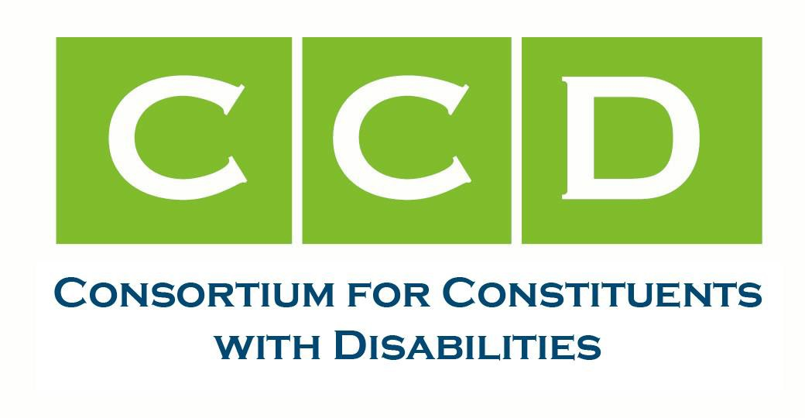

April 04, 2024
Honorable Maria Cantwell
Chair, U.S. Senate Committee on Commerce, Science, and Transportation Honorable Ted Cruz
Ranking Member, U.S. Senate Committee on Commerce, Science, and Transportation

Honorable Cathy McMorris Rodgers Chair, U.S. House Committee on Energy and Commerce
Honorable Frank Pallone
Ranking Member, U.S. House Committee on Energy and Commerce

Dear Sen. Cantwell, Sen. Cruz, Rep. McMorris Rodgers, and Rep. Pallone:
The undersigned members of the Consortium for Constituents with Disabilities (CCD) Technology and Telecommunications Task Force write in strong support of S.2494 / H.R.4858, the Communications, Video, and Technology Accessibility Act (CVTA). We urge Congress to pass the CVTA. In addition, we call on Senate Commerce, Science, and Transportation Committee and the House Energy and Commerce Committee to hold bipartisan hearings on the barriers to accessing communications, technology, and video services and the benefits that people with disabilities receive when these services are fully accessible and available.
CCD is the largest coalition of national organizations working together to advocate for federal public policy that ensures the self-determination, independence, empowerment, integration and inclusion of children and adults with disabilities in all aspects of society. The Telecommunications and Technology Task Force deals with issues related to access to telecommunications and assistive technology in education, employment, and independent living.
The CVTA would ensure that people with disabilities have access to the innovative communication and video programming technologies needed to participate equally in employment, education, recreation, civic, and other parts of society. This legislation builds upon the 21st Century Communications and Video Accessibility Act (CVAA) of 2010 by establishing federal accessibility requirements needed to keep pace with these essential products and services as they continue to evolve.
Some of the most important parts of the CVTA include:
- Requiring closed captioning and audio description for online video programming that mirrors current televised video programming captioning requirements;
820 First Street, NE Suite 740 • Washington, DC 20002 • PH 202-567-3516 • FAX 202-408-9520 • Info@c-c-d.org • www.c-c-d.org

- Requiring video programming devices, such as televisions, to include features that allow easy use of closed captioning and audio description and compatibility with assistive technologies, such as braille, sip & puff, and voice control technologies, used by people with vision, manual dexterity, and speech disabilities;
- Requiring video conferencing services to have built-in accessibility features and the ability to connect with assistive technologies, including ASL interpreters, captioning, telecommunications relay services (TRS), screen readers, braille displays, and hands-free and voice-control technologies;
- Expanding the National DeafBlind Equipment Distribution Program to reach more eligible people who would benefit from accessible communications devices;
- Ensuring that deaf people have equitable access to 911 emergency services;
- Expanding the TRS program to better assist ASL users and people who are DeafBlind or have speech disabilities; and
- Empowering the FCC to ensure that its accessibility regulations keep pace with emerging technologies, such as artificial intelligence and virtual reality.
This legislation will make existing accessibility requirements stronger, providing people with disabilities greater access to the digital world. People who are blind, low vision, deafblind, deaf, and hard of hearing as well as people with speech, cognitive, and learning disabilities will benefit from the CVTA. According to the American Community Survey, more than 12 million people in the US have a hearing disability, more than 8 million have a vision disability, more than 17 million people have a cognitive disability, and more than 15 million people have an independent living disability. Millions of disabled people in the US will benefit from expanded access to digital communications services, including telehealth, and video programming, including educational video content.
Given the significant benefits of this legislation, the undersigned organizations urge Congress to pass the CVTA and to hold hearings on this legislation and communications and video programming access issues. Thank you in advance for working to create opportunities and access for people with disabilities.
Sincerely,
Access Ready Inc.

CC:
Senator Edward Markey Representative Anna Eshoo

Senator Ben Ray Lujan, Chair, Subcommittee on Communications, Media, and Broadband
Senator John Thune, Ranking Member, Subcommittee on Communications, Media, and Broadband
Representative Bob Latta, Chair, Subcommittee on Communications and Technology Representative Doris Matsui, Ranking Member, Subcommittee on Communications and
Technology

