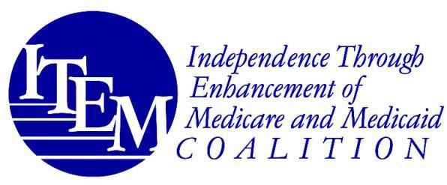

March 21, 2024
The Honorable Maggie Hassan The Honorable Mike Braun
c/o Jasmine Masand c/o Jacob Chebowski
324 Hart Senate Office Building 404 Russell Senate Office Building
United States Senate United States Senate
Washington, DC 20510 Washington, DC 20510

RE: ITEM Coalition Support for S. 3621, the Medical Device Nonvisual Accessibility Act of 2024
Dear Senators Hassan and Braun:
The undersigned members of the Independence Through Enhancement of Medicare and Medicaid (“ITEM”) Coalition write to express our support for S. 3621, the Medical Device Nonvisual Accessibility Act of 2024. We applaud your leadership in sponsoring this bipartisan legislation that would require the Food and Drug Administration (“FDA”) to develop rules requiring that new medical devices with digital displays, such as blood pressure monitors and insulin pumps, include accessible features for blind or visually impaired users. We look forward to working with you and your colleagues to enact this bill into law.
The ITEM Coalition is a national consumer- and clinician-led coalition advocating for access to and coverage of assistive devices, technologies, and related services for persons with injuries, illnesses, disabilities, and chronic conditions of all ages. Our members represent individuals with a wide range of disabling conditions, as well as the providers who serve them, including limb loss and limb difference, multiple sclerosis, spinal cord injury, brain injury, stroke, paralysis, cerebral palsy, spina bifida, hearing, speech, and visual impairments, myositis, and other life-altering conditions.

The Medical Device Nonvisual Accessibility Act is designed to improve access to home medical devices for blind and visually impaired individuals, allowing for overall better health outcomes and improved ability to maintain full independence and control over their own healthcare.
The rapid evolution of digital technology has resulted in more intricate user interfaces for common products, including critical medical devices. Many of these new devices rely on visual displays and require users to interact with on-screen menus and interfaces, posing challenges for consumers who are blind or have low vision.

Ensuring access to assistive medical devices is a longstanding priority for the ITEM Coalition.
Accessible medical devices are critical to ensure that individuals who are blind or have
low-vision are able to benefit from their usage privately, independently, and safely. The ITEM Coalition strongly supports the implementation of nonvisual accessibility standards for medical

devices used in the home. Ensuring that medical devices are designed with nonvisual accessibility features will have the potential to greatly improve the overall healthcare experience and quality of life of individuals with blindness or low vision. We support this impactful legislation.
************
For additional information about the ITEM Coalition, please contact the ITEM Coalition co-coordinators, Peter Thomas at Peter.Thomas@PowersLaw.com, Leela Baggett at
Leela.Baggett@PowersLaw.com, and Michael Barnett at Michael.Barnett@PowersLaw.com. Sincerely,

The Undersigned Members of the ITEM Coalition

Access Ready Inc.
American Council of the Blind
Assistive Technology Industry Association International Eye Foundation
Perkins School for the Blind Prevent Blindness
Prevention of Blindness Society of Metropolitan Washington The Vision Council
* ITEM Coalition Steering Committee Member

Other Supporting Organizations
EyeSight Foundation of Alabama

2

