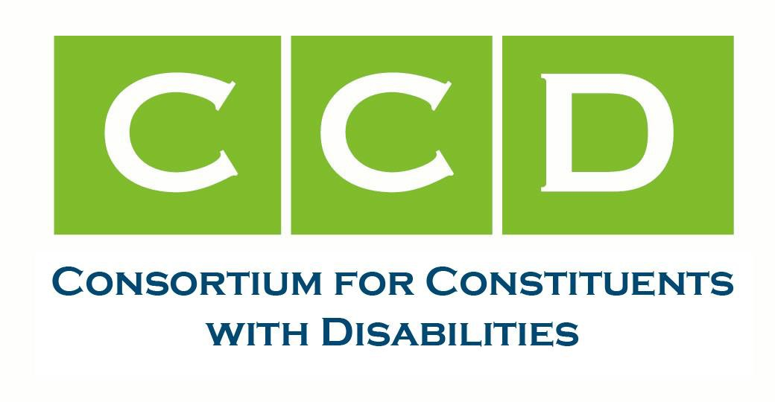
March 18, 2024 Mr. Brent Parton
Principal Deputy Assistant Secretary for Employment and Training Employment & Training Administration
Department of Labor 200 Constitution Ave NW Washington, DC 20210

RE: Docket No. ETA-2023-0004 - National Apprenticeship System Enhancements Dear Mr. Parton,
The Consortium for Constituents with Disabilities (CCD) is the largest coalition of national organizations working together to advocate for federal public policy that ensures the self-determination, independence, empowerment, integration and inclusion of children and adults with disabilities in all aspects of society, free from racism, ableism, sexism, and xenophobia, as well as LGBTQ+ based discrimination and religious intolerance.

In support of CCD’s overall mission, the Education Task Force advocates for federal legislation, regulations, and guidance that protect civil rights, ensure high expectations, and address the educational, as well as the social and emotional needs of infants, children and youth with disabilities and their families. In this work, we focus on the Individuals with Disabilities Education Act (IDEA), the Every Student Succeeds Act (ESSA), Section 504 of the Rehabilitation Act, the Americans with Disabilities Act (ADA), and other applicable laws.

The Employment and Training Task Force concerns itself with policies and programs aﬀecting people with disabilities’ ability to achieve economic self-suﬃciency through competitive, integrated employment.
People with disabilities including veterans with disabilities continue to experience challenges in becoming employed. Through our advocacy work, we focus on key policies concerning employment opportunities for people with disabilities through the Workforce Innovation and Opportunity Act.

Together, our Task Forces share the U.S. Department of Labor’s commitment to expanding access to diverse, equitable, inclusive, and accessible (DEIA) pre-apprenticeship, apprenticeship, and Career and Technical Education (CTE) programs for people with disabilities. In the NPRM, Exhibit 15—Demographic Comparison Between U.S. Census Workforce and Registered Apprenticeship Program shows that disabled people comprise 4.94% of the U.S. Workforce in the Census, but only 1.12% of people in

Registered Apprenticeship Programs. This signiﬁcant underrepresentation indicates a need to make registered apprenticeship opportunities more accessible and inclusive of people with disabilities. Most recently, the CCD has commented to the U.S. Congress and the U.S. Departments of Education and Labor on the importance of the Workforce Innovation Opportunity Act (WIOA) and other career, technical education and employment policies (e.g., apprenticeships and work based learning) to improve educational opportunity and the employment status of people with disabilities. Consistent with our shared commitment to DEIA in apprenticeships, we oﬀer the following recommendations and comments:

Deﬁnitions
§ 29.2. Addition of the [federal] deﬁnition of ‘‘major life activities’’.

CCD Response: We support the addition and consistency between the National Apprenticeship System and the Americans with Disabilities Act (ADA).

§ 29.2: ADD NEW deﬁnition: Universal Design for Learning (UDL)
Universal Design for Learning has the meaning given the term in section 103 of the Higher Education Act of 1965 (20 U.S.C. 1003).

CCD Response: The addition of the deﬁnition [and term]-Universal Design for Learning (UDL)- as included in the Higher Education Act¹ and referenced by Perkins² and the Elementary and Secondary Education Act³ will create consistency with federal education and employment law, and will assure the updates to both Subparts A and B include UDL consistent with best practices in apprenticeship programs. Speciﬁcally, we point to DOL’s recommendation to apprenticeship programs in 2020 which said:
…(UDL) oﬀers a way for organizations to improve their programs and services while addressing accessibility concerns and increasing the pool of qualiﬁed candidates. UDL is an evidence-based framework that educators use to systematically plan for and address learner diﬀerences through the design and implementation of inclusive training practices. UDL guidelines may be applied to the recruitment, assessment, workplace training, and related instruction eﬀorts that make up apprenticeship programs, as well as to general approaches to oﬀering supportive services. UDL oﬀers the greatest impact when it is used during the program design stage as program designers consider how to: convey information that any learner can understand; eﬀectively assess what a learner comprehends; and maximize a learner’s motivation and perseverance.⁴

Subpart A—Standards for Registered Apprenticeship Programs

§ 29.8(a)(6) Standards of apprenticeship. Amend. (in bold and highlights)

¹ See Public Law No. 110-315 (08/14/2008), pg. 12 at: https://www.govinfo.gov/content/pkg/PLAW-110publ315/pdf/PLAW-110publ315.pdf
² See: Public Law No. 115-224 (07/31/2018) at: https://www.congress.gov/bill/115th-congress/house-bill/2353/text
³ See: Public Law No. 114-95 (12/10/2015) at: https://www.congress.gov/114/plaws/publ95/PLAW-114publ95.pdf
⁴ Apprenticeship Inclusion Models: Using UDL in Apprenticeship, (2020), U.S. Department of Labor, at: https://www.dol.gov/sites/dolgov/ﬁles/ODEP/pdf/UsingUniversalDesignforLearninginApprenticeship.pdf

(6) The related instruction provider(s) and the instructional methods used to deliver the related instruction, which may include the application of the principles of universal design for learning;

CCD Response: As noted above, DOL has recommended UDL as an evidence-based practice for apprenticeship programs. Speciﬁcally and in reference to instructors, DOL said this, “UDL is a framework for instructors and program designers to systematically plan for and address learner diﬀerences through the design and implementation of inclusive educational and training practices.”⁵ Additionally, CCD has long advocated that all federal investments in education and career training must assure that instructors of all kinds are trained and knowledgeable in the use of UDL and other evidence based practices that are known to support DEIA.

29.9 Apprenticeship Agreements
§ 29.9(c)(9): Amend. Apprenticeship agreements. (in bold and highlights)

- A description of the methods used during the course of the apprenticeship to measure progress on competency attainment and the program’s end-point assessment which may include the application of the principles of universal design for learning;

CCD Response: As per 29.9, CCD agrees with the adding of a new requirement for the apprenticeship agreement to include a description of the methods used during the course of the apprenticeship to measure progress on competency attainment and the program’s end-point assessment and recommends adding the allowable use of and application of the principles of universal design for learning.
Additionally, to strengthen access to apprenticeships for all learners, including those with disabilities, CCD recommends that Apprenticeship agreements encourage and assure that the principles of UDL may apply. Furthermore, we agree with DOL that “the [approved] methods should be inclusive and accessible to all apprentices, including those with disabilities and others from underserved communities.”

§ 29.9(c) (10). Amend. (in bold and highlights)
At a minimum, the apprenticeship agreement must contain the following:

- A description of any supportive services that may be available to the apprentice including childcare, transportation, counseling services, ﬁnancial literacy training, beneﬁts counseling, access to job coach or mentor, equipment, tools, or any other supportive service provided by the sponsor or a partnering organization to address potential barriers to participation or completion.

CCD Response: CCD supports apprentices having access to a broad range of career and supportive services that enable their participation in the apprenticeship program. CCD recommended the inclusion of supportive or wraparound services that would beneﬁt people with disabilities like counseling services, ﬁnancial literacy training, beneﬁts counseling, and access to a job coach or mentor.

⁵ Ibid.

29.10 Program registration.
(8) A description of how the sponsor will implement, upon registration, the aﬃrmative steps to provide EEO in apprenticeship required by § 30.3(b) of this title. This description must, at a minimum:

- Provide a list of current recruitment sources that will generate referrals from all demographic groups within the relevant recruitment area, including the identity of a contact person, mailing address, telephone number, and email address for each recruitment source;
- Describe the sponsor's procedures to ensure that its apprentices are not harassed or otherwise subjected to discrimination because of their race, color, religion, national origin, sex, sexual orientation, age (40 or older), genetic information, or disability and to ensure that its apprenticeship program is free from intimidation and retaliation.

CCD Response: CCD supports this provision.

§ 29.12(c)(2) Qualiﬁcations of apprentice trainers and providers of related instruction. Amend. (in bold and highlights)

(2) Have received previous training in teaching techniques and adaptable learning styles, which may incorporate the principles of universal design for learning.

CCD Response: Consistent with the recommendation made in § 29.8(a)(6) regarding instructors and instructional practices, CCD recommends that programs be encouraged and allowed to incorporate the principles of UDL when considering the qualiﬁcations of apprentice trainers and providers of related instruction. Because these trainers tend to come from speciﬁc industries and are experts in their trade, craft or careers, there is great beneﬁt in providing these experts of industry with some level of professional learning that demonstrates how they can ﬂexibly adapt their teaching style to better identify the range of learning needs and eﬀectively teach diverse learners who may experience barriers to learning due to literacy level/skill, English language acquisition and/or disability.

29.16 End-point assessment and Certiﬁcate of Completion.

§ 29.16. Amend (a).

(a) Prior to an apprentice’s completion of the registered apprenticeship program, the program sponsor must arrange for an end-point assessment which may incorporate and apply the principles of universal design for learning to objectively measure the apprentice’s acquisition of the relevant knowledge, skills, and competencies necessary to demonstrate proﬁciency in the occupation covered by the program.

CCD Response: CCD supports the establishment of an endpoint assessment that is inclusive to all apprentices, including those with disabilities. As previously noted above, the National Assessment

Programs would beneﬁt greatly from articulating clearly that it is allowable (and encouraged) that such assessment(s) incorporate UDL which would ensure that all apprentices, regardless of literacy level, language skill, and/or disability have access to an assessment that is designed with diversity, equity, inclusion and accessibility in mind.

(c) The sponsor must inform all apprentices of their right to request a reasonable accommodation prior to the administration of the assessment.

CCD Response: CCD supports proposed 29.16(c) that is intended to ensure that registered apprenticeship programs are fully accessible to job seekers, including those with disabilities that may require reasonable accommodations.

To strengthen 29.16, CCD recommends that the U.S. Department of Labor, Employment and Training Administration, Oﬃce of Apprenticeship (OA) take steps to inform apprentices of their rights, as well provide information and support for securing the necessary accommodations.

While CCD takes no position on whether assessments should be performed by independent or third parties or those operating a program, we urge that the selection of an independent or third party assessor take into consideration the necessity to provide reasonable accommodations as required by the ADA, especially if a third party is assessing the apprentice.

Subpart B—Career and Technical Education Apprenticeship

§ 29.24(b). Approval of Industry Skills Framework

CCD Response: CCD supports the provision to establish industry skills frameworks as a distinct requirement and component of registered CTE apprenticeship that would be required to be included in registered CTE apprenticeship program standards. See below for recommended additions.

§ 29.24(2)(b)(1)(i). Amend. Approval of Industry Skills Framework (in bold and highlights)

(i) Provides a structure for developing the professional behaviors, workplace competencies, and theoretical knowledge required by an industry, that may include the principles of universal design for learning;

CCD Response: CCD supports DOL’s intent to establish industry skills frameworks as a distinct requirement and component of registered CTE apprenticeship and the requirement they be included in registered CTE apprenticeship program standards. We believe the provision will be strengthened by clarifying that the principles of UDL may be applied. There are programs utilizing UDL and the addition here will greatly expand the ability to replicate use and broaden access to diverse, equitable, inclusive and accessible CTE apprenticeships.

§ 29.24(c). Standards of registered CTE apprenticeship. Amend. (in bold and highlights)

(c) Standards of registered CTE apprenticeship. Each registered CTE apprenticeship program must have a written set of standards of registered CTE apprenticeship that will govern the conduct and operation of that program; such standards may include the principles of universal design for learning and must include the following provisions:

CCD Response: CCD supports that each registered CTE apprenticeship program must have a written set of standards to govern the conduct and operation of the program. Given the documented success of such programs including UDL, we believe making the application of UDL allowable as standards are set and documented will ensure CTE apprenticeship programs will plan for and expand capacity to utilize UDL knowing that such use will strengthen CTE apprenticeship program outcomes.

29.25 Collection of data and quality metrics concerning apprenticeship.
(a) Apprentice information.
- Within 30 calendar days of the start of an apprentice's participation in a registered apprenticeship program, the program sponsor must submit to its Registration Agency, in a format prescribed by the Administrator, the following information:
  - Individual apprentice level information that includes demographic information, education level, and veteran status;

- Information and reports to be made publicly available by the Registration Agency.
  - The Registration Agency will make publicly available on an annual basis general information relating to registered apprenticeship programs along with the information described in paragraph (b)(2) of this section.

  - The Registration Agency will make publicly available an annual State or national summary report of apprentices and their outcomes, disaggregated by race, ethnicity, sex, disability status, and other categories determined by the Administrator.

CCD Response: CCD supports this requirement.

We appreciate the Administration’s eﬀort to create inclusive and high-quality opportunities for people with disabilities to participate in pre-apprenticeship, apprenticeship, and CTE programs. We look forward to working with both the U.S. Department of Labor and the U.S. Department of Education to ensure the needs of all participants are fully met. If you have any questions or concerns, please reach out to one of the CCD Education Task Force Co-Chairs or Employment and Training Task Force Co-Chairs listed below.

Sincerely,
<Organizations>

CCD Education Task Force Co-Chairs CCD Employment and Training Task Force

Co-Chairs

Stephanie Flynt
National Disability Rights Network (NDRN) Stephanie.ﬂynt@ndrn.org
Julie J. Christensen, PhD, LMSW Association of People Supporting EmploymentFirst (APSE) julie@apse.org

Laura Kaloi
Council of Parent Attorneys and Advocates and the Center for Learner Equity lkaloi@stridepolicy.com
Bart Devon Eggleston Services
bdevon@egglestonservices.org

Lindsay Kubatzky
National Center for Learning Disabilities lkubatzky@ncld.org
Alicia Epstein SourceAmerica
aepstein@sourceamerica.org

Robyn Linscott
The Arc of the United States linscott@thearc.org
Mike Nagel
The Arc of the United States Nagel@TheArc.org

Kim Musheno Autism Society
kmusheno@autismsociety.org
Rick Webster
National Industries for the Blind (NIB) rwebster@nib.org

