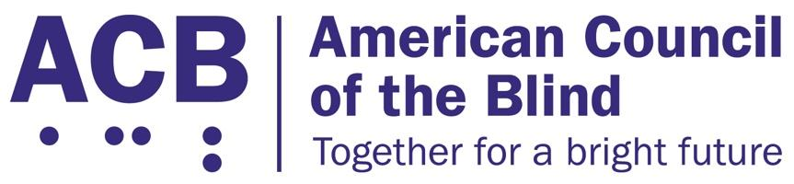
225 Reinekers Ln., Suite 660
Alexandria, VA 22314
Tel: (202) 467-5081
Fax: (703) 465-5085

February 14, 2024

Kristin Clark
Assistant Attorney General for Civil Rights
U.S. Department of Justice
950 Pennsylvania Avenue, NW
Washington, DC 20530-0001

Shailen Bhatt
Administrator
Federal Highway Administration
U. S. Department of Transportation
1200 New Jersey Ave. SE
Washington, DC 20590

RE: PROWAG NPRMS

Dear Assistant Attorney General Clark and Administrator Bhatt:

My name is Deb Cook Lewis, and I am President of the American Council of the Blind (ACB). ACB is a 501(c)(3) nonprofit member driven advocacy organization that, With its 66 affiliates, strives to increase the security, independence, economic opportunity, and quality of life for Individuals who are blind, experiencing vision loss or who have both hearing and vision loss (“the blindness community” or “people who are blind”). During the organization's more than 60-year history, ACB has become a leader in national, state, local, and even international advocacy efforts.

As we discuss more fully below, ACB has grave legal, safety, and equity concerns about the Access Board’s Public Right-of-Way Accessibility Guidelines (PROWAG) because it expressly permits continuing use of existing, inaccessible pedestrian signals which are invisible to and unusable by the blindness community. Were the Department of Justice (DOJ) or the Department of Transportation (DOT) to adopt Final PROWAG as an ADA Legal Standard to allow the ongoing use of visual-only pedestrian signals until new construction or an alteration occurs, such regulations would discriminate on the basis of disability, i.e., blindness, and would constitute an unlawful federally conducted program or activity in violation of Section 504 of the Rehabilitation Act. American Council of the Blind v. Paulson (525 F.3d 1256, 1273 (D.C. Cir. 2008), “Where the plaintiffs identify an obstacle that impedes their access to a government program or benefit, they likely have established that they lack meaningful access to the program or benefit.”
Specifically, a pedestrian signal is inaccessible if it displays the “Walk” and “Don’t Walk” signal status in an exclusively visual format, until it is equipped with an accessible pedestrian signal (APS) which provides the equivalent signal information in an audible and vibrotactile manner, which is accessible and usable by people who are blind, low vision or deafblind.

Courts have recognized that people who are blind are entitled to “meaningful access” to a public entity’s network of pedestrian signals under Title II of the ADA and Section 504. A pedestrian signalized network using visual only pedestrian signals constitute a denial of “program access” and failure to provide auxiliary aids and services to ensure effective communication and a failure to accommodate pedestrians who are blind.

Based upon the authorities discussed more fully below, ACB asks that your agencies’ PROWAG-related Notices of Proposed Rulemaking (NPRMs) seek to amend the ADA Title II regulations to expressly:
- Prohibit the use of visual only pedestrian signals unless equipped with APS and to otherwise require that an accessible public right-of-way include the adoption of APS on all visual only pedestrian signals.
- Require a public agency to adopt and fund an ADA Transition Plan which would equip all existing visual only pedestrian signals with APS within five years.
- Equip pedestrian signals with APS immediately in new construction and alterations to visual only pedestrian signals.
- Prioritize the installation of APS when requested by a visually impaired resident and to speedily remediate any Leading Pedestrian Interval (LPI) or Exclusive Pedestrian Phase (EPP) signal timing with APS.
- Define the term “alteration” in PROWAG to explicitly include changes to signal timing in order to apply to any use of an LPI or an EPP in a pedestrian signal.
- Ensure that all APS are activated and maintained in proper working order.

I. Title II of the ADA and Section 504 Grant a Right to Meaningful Access to a Public Entity’s Visual Only Pedestrian Signals, requiring “effective communication” of the Walk Interval for Blind Pedestrians.

Even before PROWAG was adopted by the Access Board, multiple federal courts had recognized a current right to “meaningful access” to a Public Entity’s pedestrian Signalized network, thereby Requiring “Effective Communication” through the installation of APS. ACB affiliates, chapters, and individual members have successfully sued cities, including New York and the City of Chicago, to compel them to install APS pursuant to Title II of the ADA and Section 504 of the Rehabilitation Act. Scharff v. City. of Nassau, No. 10 CV 4208 DRH AKT, 2014 WL 2454639, at *7 (E.D.N.Y. June 2, 2014) (“[t]he act of installing and maintaining pedestrian crossing signals at crosswalks is a normal function of the County, and therefore falls within the scope of Title II and the Rehabilitation Act.”); ACB of Metropolitan Chicago v. City of Chicago, 2023 WL 2744596 (N.D. Ill, Mar. 31, 2023); ACB of New York v. City of New York, 495 F.Supp. 3d 211 (S.D.N.Y. 2020). The latter court subsequently ordered New York City to install 10,000 APS at signalized intersections within ten years and to complete installation of APS at its approximately 13,000 signalized intersections within fifteen years. American Council of the Blind of New York v. City of New York, 579 F.Supp.3d 539 (S.D.N.Y. 2022).

Moreover, the United States intervened as a plaintiff in the ACB of Metropolitan Chicago v. City of Chicago litigation and prevailed in its APS-related claims against that City.

Separately, the Federal Highway Administration (FHWA) recognized the authority of the ADA APS litigation cited above in the preamble to the Final Rule for the 11th edition of the Manual on Uniform Traffic Control Devices. See: 88 FR 87672, *87688(Dec. 19, 2023). Ignoring this caselaw, PROWAG unlawfully disregards the existing right to APS, and instead conditions this obligation based upon a public entity’s voluntary decision to undertake new construction of or an alteration to a visual only pedestrian signal at an uncertain time in the future. For example, the Access Board’s PROWAG Regulatory Impact Analysis (RIA) finds that it might take 25 years for a visual only pedestrian signal to reach the end of its life cycle, requiring its replacement with a pedestrian signal equipped with an APS. https://www.regulations.gov/document/ATBCB-2011-0004-0610at 4.4.3.1. This is an unacceptable and unnecessary denial of a current right to “meaningful access” to a pedestrian signalized network of street crossings, in violation of ADA Title II and Section 504.

II. PROWAG’s Disregard of the Blindness Community’s Right to APS Creates an Unacceptable and Unnecessary Risk of Injury or Death to the Blindness Community.

The denial of APS to people who are blind creates an unnecessary and unacceptable higher risk of injury or death to blind pedestrians. A visual-only pedestrian signal is invisible to a blind pedestrian. A sighted pedestrian can watch oncoming vehicles and also see the signal. By contrast, without accessible Walk/Don’t Walk information, a blind pedestrian has only their hearing to rely on to read parallel and oncoming traffic to judge when it might be safe to cross. Background noise, quiet cars, e-bikes, left and right turn on red, and unfamiliar street designs make crossing a busy street a hazardous endeavor for the blindness community. Moreover, unnecessary, additional risk to blind pedestrians is created by the growing use of Leading Pedestrian Intervals at pedestrian signalized crossings, an FHWA-promoted safety countermeasure, which benefits the sighted but risks harm to people who are blind. An LPI gives an early “Walk” signal, enabling sighted pedestrians to begin crossing and be more visible to drivers before vehicles are released to cross an intersection. Unaware of the early “Walk” signal, however, a blind walker is trained to listen for a parallel traffic surge before beginning to cross. This may cause the blind pedestrian to begin their crossing just as traffic begins to turn across the intersection, right when drivers are not expecting to find a pedestrian in the street crossing.

The greater risk to blind pedestrians resulting from visual-only pedestrian signals also must be understood in the context of the extremely high number of pedestrian fatalities. The Governors Highway Safety Association estimates that 7,508 pedestrians were killed in 2022, the highest number since 1981. GHSA - Pedestrian Traffic Fatalities by State, 2022 Preliminary Data (January-December).pdf

Moreover, 76% of pedestrian fatalities occur at night because of poor visibility for walkers and drivers. While the number of blind pedestrians killed is unknown, the higher nighttime fatality rate supports an inference that blind people will have a higher fatality rate than sighted pedestrians.

III. PROWAG Should Be Interpreted to expressly Recognize A Right to APS in the Public Right-of-Way Consistent with the IIJA’s Policies and Programs to Protect the Safety of Vulnerable Road Users Including All People with Disabilities.

The safety of pedestrians, including vulnerable road users like blind walkers, should guide the interpretation of ADA Title II and Section 504 when creating PROWAG-related ADA Legal Standards pertaining to APS. In particular, the DOJ and DOT NPRMs should recognize that one critically important goal of the Infrastructure Investment and Jobs Act (IIJA), Pub. L. No. 117-58 (Nov. 15, 2021), was to improve highway safety and reduce our nation’s unacceptable level of roadway injuries and deaths. It is not surprising, therefore, that the word “safety” occurs 843 times in the IIJA’s text. By way of example, the IIJA established or continued the following, non-exclusive list of safety-related programs and requirements:
- State Strategic Highway Safety Program
- State Highway Safety Improvement Program
- Safe System Approach (which “emphasizes minimizing the risk of injury or fatality to road users.”)
- Safe Routes to School
- Comprehensive Safety Action Plan (which aims at preventing transportation-related fatalities and serious injuries in a locality, commonly referred to as a “Vision Zero” or “Toward Zero Deaths” plan.)
- Adoption of Complete Streets Standards for policies to improve the safety, mobility, or accessibility of a street.
- State Mandated Vulnerable Road User Safety Assessment.

The IIJA incorporates a national policy directed toward reducing roadway fatalities and protecting “vulnerable road users,” specifically including pedestrians and people with disabilities. This national policy strongly supports ACB’s request that the PROWAG NPRMs mandate equipping APS on all visual only pedestrian signals within five years. Moreover, IIJA provides a significant increase of federal funding and discretionary, competitive grants which a public entity may apply for, directly to the FHWA or indirectly, through its State DOT or its Metropolitan Planning Organization, to reimburse it for APS-related costs. This additional, new federal funding significantly reduces the financial burden on public entities of requiring APS installations within five years.

Equity also demands that there be parity in the rights afforded to people of different disabilities. Pedestrian signals equipped with APS for people who are blind serve the analogous accessibility and safety functions that curb ramps on sidewalks serve for people who use wheelchairs and TDD access to emergency services serve for people who are deaf.

Thank you for considering this request when drafting your PROWAG-related proposed rules. Should you have any questions, or should you desire to meet to discuss these matters, please contact Claire Stanley, ACB’s Director of Advocacy and Government Affairs at (202) 559-2041or at cstanley@acb.org.

Sincerely,

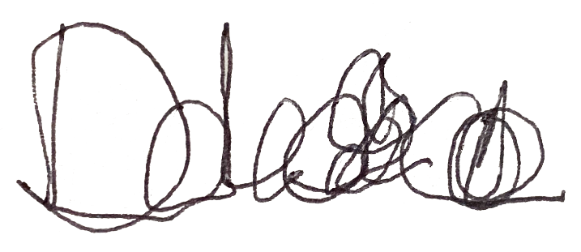

Deb Cook Lewis
President

Cc: (By E-Mail)
Dr. Sachin Dev Pavithran
Executive Director
ATBCB

Rebecca Bond
Chief, Disability Rights Section
Civil Rights Division
DOJ

Kelly Buckland
Office of the Secretary
DOT

Terence Carlson
Department of Transportation
Office of the Secretary
1200 New Jersey Avenue SE
Washington, DC 20590
Phone: (202) 366-4000
Email: terence.carlson@dot.gov

Doug Towne
Chair and CEO
Access Ready Inc.

