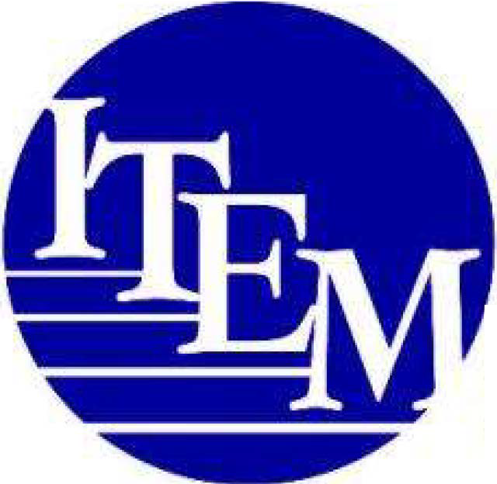
Independence Through Enhancement of Medicare and Medicaid COALITION

February 15, 2024

SUBMITTED ELECTRONICALLY

The Honorable Jack Bergman
U.S. House of Representatives
566 Cannon House Office Building Washington, DC 20515

The Honorable Mike Bost Chairman
House Committee on Veterans' Affairs 352 Cannon House Office Building Washington, DC 20515

The Honorable Debbie Dingell
U.S. House of Representatives
102 Cannon House Office Building Washington, DC 20515
The Honorable Julia Brownley
Ranking Member, Health Subcommittee House Committee on Veterans' Affairs 2262 Cannon House Office Building Washington, DC 20515



RE: ITEM Coalition Support for H.R. 6373, the Veterans STAND Act of 2023

Dear Representatives Bergman, Bost, Brownley, and Dingell:
On behalf of the undersigned members of the Independence Through Enhancement of Medicare and Medicaid ("ITEM") Coalition, we write to express our support for H.R. 6373, the Veterans Spinal Trauma Access to New Devices (STAND) Act of2023. Thank you for your sponsorship of this bipartisan legislation which would direct the Secretary of Veterans Affairs to offer annual preventative health evaluations to veterans with spinal cord injuries or disorders and increase access to state-of-the-art assistive mobility technologies, such as Exoskeletal systems, which allow paralyzed veterans the ability to walk again.

The ITEM Coalition is a national consumer- and clinician-led coalition advocating for access to and coverage of assistive devices, technologies, and related services for persons with injuries, illnesses, disabilities, and chronic conditions of all ages. Our members represent individuals with a wide range of disabling conditions, as well as the providers who serve them, including spinal cord injury, paralysis, limb loss and limb difference, multiple sclerosis, brain injury, stroke, cerebral palsy, spina bifida, hearing, speech, and visual impairments, myositis, and other life-altering conditions.

Access to and coverage of new and emerging technologies is a long-standing priority for the ITEM Coalition. Exoskeletons are wearable assistive technology devices that provide powered hip and knee motion to enable individuals with spinal cord injury (SCI) to stand upright, walk, turn, and even ascend and descend stairs, thereby allowing them to function more independently and take part in community activities. The VA estimates that approximately 42,000 individuals

1501 M Street NW, 7h Floor• Washington, DC 20005• www.itemcoalition.org• 202-466-6550


with spinal cord injuries are U.S. Veterans, of which the VA provides annual care to more than 27,000 individuals through the VA Spinal Cord Injuries and Disorders (SCI/D) network. The Veterans STAND Act, which has been previously endorsed by a number of ITEM Coalition members, including Paralyzed Veterans of America, seeks to ensure the following:

- Annual exoskeleton evaluations are codified in law for those Veterans who seek their care through the VA;
- VA provides Congress updates on the progress in terms of numbers of evaluations, training, and device approvals;
- Exoskeleton manufacturers and other external stakeholders are included when considering changes to the clinical practice guidelines published at VA governing the evaluation, training, and procurement of exoskeleton devices; and
- Appropriate usage of exoskeleton devices becomes a measurable element of the overall performance metrics for leadership within existing Veteran Integrated Service Networks (VISNs), or VA regions.

Ensuring that paralyzed veterans are able to have access to and coverage of this life-changing technology is critical to the ITEM Coalition's mission. For these reasons, we are proud to support this bill and we look forward to working with you and your colleagues in the House to pass this important piece of legislation into law.

Should you have any further questions, please contact Peter Thomas or Michael Barnett, ITEM Coalition coordinators, at Peter.Thomas@PowersLaw.com and Michael.Barnett@PowersLaw.com or by phone at 202-466-6550.
Sincerely,
Access Ready Inc.

2

