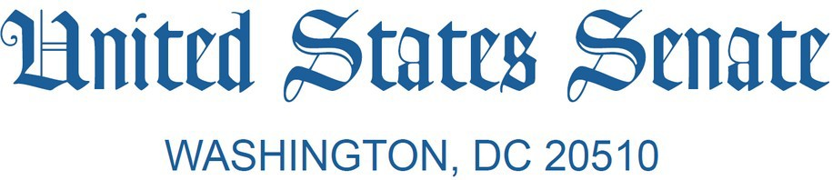
December 3, 2025
The Honorable Linda McMahon Secretary
U.S. Department of Education 400 Maryland Ave, SW Washington, DC 20202

Dear Secretary McMahon:

The actions you announced on November 18 to continue hollowing out the U.S. Department of Education (“the Department”) are outrageous, illegal, and will jeopardize the funding and support that tens of millions of students, teachers, and families across the country rely on. Your brazen attempt to dismantle the Department by transferring to other federal agencies complex and foundational responsibilities that Congress specifically charged to the Department—including more than half of all federal funds for elementary and secondary education programs and billions in higher education funding—will undermine public education. This is the latest example of this administration’s complete lack of regard for our laws and its failure to provide the certainty, clarity, and stability that students and schools deserve when it comes to the federal government’s approach and commitment to properly implementing federal education laws and appropriations.
Let’s be very clear: You are choosing to create even more bureaucracy that states, school districts, and educational institutions across America will have to expend time and resources navigating at the expense of students and families. We urge you to immediately reverse course and to focus your time and attention on actions that actually help states, school districts and educational institutions improve educational outcomes and support for students. We expect you to work with Congress to pursue any ideas to streamline programs and improve public education, as the law and the Constitution require, and you have yourself stated you would do in your confirmation hearing.¹
The Department of Education is the only federal agency whose sole mission is to help children learn and improve their educational outcomes. The Department delivers much-needed federal funding and enforces basic educational guardrails and civil rights protections so that every child can get the quality public education that they are entitled to under the law, no matter who they are or where they live. Congress has unambiguously authorized dozens of education programs to be administered by the Department through numerous laws² and has clearly appropriated funding

¹ McMahon response to Chair Cassidy: “We would like to do this right. We would like to make sure that we are presenting a plan that I think our Senators could get on board with and our Congress could get on board with that would have a better functioning Department of Education. But certainly, it does require Congressional action.” Nomination of Linda McMahon to serve as Secretary of Education, U.S. Senate Committee on Health, Education, Labor, and Pensions, February 13, 2025.
² For example, the Elementary and Secondary Education Act, the Higher Education Act, the Carl D. Perkins Career and Technical Education Act, the Individuals with Disabilities Education Act, and the Rehabilitation Act.

on a bipartisan basis for decades to the Department to carry out those programs. Appropriations law prohibits the transfer of funds to another federal agency unless expressly authorized in appropriations law, which it has not done in this case. When Congress wants another agency to administer a program or function, it has expressly said so—and in some cases, it has provided authority to transfer funds to allow this to happen.³ By contrast, Congress has not expressly authorized any other agency to administer the programs established under the previously mentioned laws, nor has it provided the authority for the Department to transfer these programs and associated funding to another agency.
The November 18 announcement outlines six interagency agreements (IAAs) with the Departments of Labor, Interior, Health and Human Services, and State to transfer major responsibilities out of the Department of Education.⁴ The authorities cited in the IAAs do not enable the Department to do an end-run around the relevant authorizing and appropriating statutes. For example, the Department cites the Economy Act to justify its use of the IAA framework.⁵ While the Economy Act is routinely used by other federal agencies to enter into IAAs for the procurement of discrete goods and services that a particular agency might have expertise in and authority to provide, such as DOJ’s fingerprinting authority, this authority was never contemplated to allow the transfer of major program functions or entire offices to another agency with the express stated purpose of eventually dismantling the agency⁶ or putting the Secretary “out of a job.”⁷ Federal resources outlining the purpose of the Economy Act make this clear.⁸ This view is further affirmed by the Department’s inability to cite a single instance of using this statute or any others in a similar way prior to this year.
You have expressed your interest in working with Congress on these issues, but these IAAs were developed in secret without outside input. The fiscal year 2026 budget request for the Department makes no reference to administering these programs at other agencies and the fiscal year 2026 budget request for the U.S. Department of Labor (DOL), for example, makes no reference to administering them either. The Secretaries of Labor, Interior, State, and HHS have similarly never testified to Congress on how they would carry out and administer these critical education programs.
Since you were nominated to lead the Department, you have routinely misled the public about the level of involvement the Department has long had in the day-to-day management of schools
—inaccurately suggesting that the Department was depriving states and families from making choices about their children’s education, shackling teachers with burdensome regulations and paperwork and causing K-12 and college students to experience “drudgery caused by

³ The Workforce Innovation and Opportunity Act authorized the transfer of certain functions of the Rehabilitation Services Administration to the U.S. Department of Health and Human Services (HHS) and the Consolidated and Further Continuing Appropriations Act, 2015 permitted the Department to transfer appropriations consistent with that change in law.
⁴ https://www.ed.gov/about/news/press-release/us-department-of-education-announces-six-new-agency-partnerships-break-federal-bureaucracy
⁵ 31 USC §1535
⁶ https://x.com/PressSec/status/1991651542542303575
⁷ https://thehill.com/homenews/administration/5219563-mcmahon-trump-dead-serious-fire-myself/
⁸ https://www.acquisition.gov/far/17.502-2; https://wwwkc.fiscal.treasury.gov/files/ussgl/economy-act.pdf

administrative burdens.”⁹ On the basis of these false assertions, you have strangely claimed that we need to “Return Education to the States.”¹⁰ In fact, states and local communities have—since the founding of our republic—had the primary responsibility for educating our students and the establishment of the Department in 1979 did nothing to change that fact.¹¹ In fact, there are numerous federal laws that prevent the Department from being involved in the day-to-day decision making in schools and colleges as it relates to curriculum, teaching, and programs.¹²
Until your arrival at the Department, its role has been to provide funding, support, and oversight as authorized by federal education laws to ensure students from all walks of life and in every part of the country can get a high-quality public education. The Department’s programs ensure that parents get timely, accessible information about how their kids’ schools are doing. They ensure students with disabilities’ rights are enforced, so that they can get the education they are entitled to. The Department administers programs to help under-resourced rural school districts and allocates Impact Aid for more than 1,000 school districts with a reduced revenue base or increased costs due to a federal presence, such as a military base. It also administers programs to help first-generation and low-income students pursue and succeed in college. These are just a select few examples of the indispensable supporting role that the federal government—and the Department, in particular—plays in advancing educational outcomes for students.
To justify these new IAA’s, you say federal funding will keep flowing to states, school districts, and colleges.¹³ But we have already seen funding held up and seriously delayed because of this administration’s chaotic changes—and its extreme policies—and the moves you announced last week are certain to further jeopardize these funds.
You claim these actions will improve student achievement, yet your actions will significantly weaken federal monitoring of states’ K-12 accountability and school improvement
systems. Before Congress mandated that states develop these systems with key guardrails in the Elementary and Secondary Education Act, several states had weak or no school improvement systems, which allowed vulnerable students to slip through the cracks. As part of ESEA and subsequent appropriations directives, Congress has charged OESE with improving state compliance in state and local school report cards requirements, school improvement, and more. But without the staff expertise from OESE, it is likely that DOL will be ineffective in holding states accountable for improving student outcomes.
The Department also provides deep policy expertise to ensure programs support improved student outcomes, such as through expert guidance to colleges and universities to improve

⁹ https://www.ed.gov/about/news/press-release/statement-president-trumps-executive-order-return-power-over-education-states-and-local-communities
¹⁰ https://www.usatoday.com/story/opinion/2025/11/16/school-funding-trump-dismantle-education-department/87251723007/
¹¹ https://www.govinfo.gov/content/pkg/COMPS-726/pdf/COMPS-726.pdf
¹² 20 USC §7906a, 20 USC §6311(b)(1)(G), 6311(e); 20 USC §6575; 20 USC §6692; 20 USC §6849; 20 USC §7371; 20 USC §7886(d); 20 USC §7907; 20 USC §7861(d)(3); 20 USC §7924; 20 USC §1232a; 20 USC §1132-2; and 20 USC
§2306a
¹³ https://www.cbsnews.com/news/linda-mcmahon-federal-school-aid-education-department-duties-other-agencies/

college access, retention, and completion through programs like TRIO, GEAR UP, the Postsecondary Student Success Grant Program, and others. Now, DOL, who lacks the necessary expertise, is tasked with managing these programs and students will suffer as a result.
DOL has no prior experience in administering education programs at this scale and complexity and will need to develop the capacity and processes to allot billions of dollars in funding to state and local educational agencies. States will also have to make changes to receive any funds distributed through DOL’s grant system while continuing to draw down prior year grant funding in the Department’s system. Your IAA also seems to suggest the Department will still retain some authorities over Title I-A, which means that states will now have to work with two federal agencies when they need help navigating this complex and absolutely critical program. These changes solve exactly zero problems but manage to create an onslaught of new ones. We are very concerned that these changes will mean funds our constituents rely on will not continue to flow as intended under federal education laws.
In addition to its scope and complexity, the Title I-A program primarily funds instruction and activities in elementary schools.¹⁴ We do not believe kindergartners or other elementary school students should be the focus of efforts to integrate workforce programming and education activities, activities that are better suited to older students. Instead of improving students’ readiness for the workforce, the move of Title I-A to DOL is much more likely to deprive states and school districts of the technical assistance and support they need to effectively implement federal education funding in their schools and provide high-quality educational opportunities to all students.
DOL already has a comprehensive workload to support the nation’s workers and workforce programs. It is authorized and funded to administer workforce training and enforce worker protection programs for which Congress appropriates $13.5 billion in discretionary funding annually, including for roughly a dozen workforce training grant programs totaling approximately $4 billion in annual funding. In addition to lacking the subject area expertise needed to administer the Department’s programs, DOL does not have the grant administration capacity to take on the work outlined in the IAA; the approximately $30 billion in the Department’s funding across approximately 50 discrete formula and competitive education grant programs that you seek to transfer now to DOL dwarf its current grant administration and oversight work. Transferring basic and significant responsibilities for administering education programs to DOL creates very significant risks of delays in funding and other administrative challenges for states, school districts, institutions of higher education, and other organizations through Impact Aid, rural education programs, afterschool programs, TRIO, and foundational education formula grant programs that tens of thousands of schools count on to help provide a quality education to millions of students.
Unfortunately, we have already seen negative consequences for states, schools, colleges, and students as these IAAs roll out: the first IAA inked earlier this year between the Department and DOL on career and technical education and adult education has been plagued with serious

¹⁴ https://www.air.org/sites/default/files/2021-06/Study%20of%20Title%20I%20Schoolwide%20and%20Targeted
%20Assistance%20Programs_Final%20Report.pdf

challenges—and it is but a small fraction of what is now being transferred to DOL. In fact, as your own staff reportedly concluded in its analysis after this transfer, “The size and scope of OCTAE's programs are miniscule [sic] compared to other [Education Principal Operating Components] and programs…Larger formula grants and competitive grants are going to be much more difficult to migrate.”¹⁵ States and districts faced delays in accessing their Perkins CTE funding, and advocates report delays in guidance and training issued by DOL.¹⁶ Moreover, a CTE expert recently testified before the House of Representatives, “At a time of scarce resources, it’s hard to understand why the Department is paying Labor to do work that it can do for itself.” ¹⁷ The fiscal year 2025 funding level for Perkins CTE and adult education was $2.18 billion, whereas the other programs DOL will now be responsible for are funded at roughly $30 billion. If the administrative costs balloon under these new IAAs as the administrative costs under the CTE IAA have, not only will these IAAs be terrible for students, their families, and educators, they will also be a catastrophic waste of time and money for the American taxpayer.
The Department has provided no substantive detail or even basic information about how the significant changes envisioned by these IAAs would be implemented. The other federal agencies that will suddenly have significant responsibilities in administering billions in education funding
—have provided no information about their roles or their capacity to carry out these programs and activities. The plan seems clear—to jam these changes through for a talking point, whatever the consequences may be for states, school districts, schools, students, and families.
We once again demand that you reverse these detrimental plans and refocus your efforts on supporting state and local efforts by properly implementing federal laws intended to improve educational opportunities and outcomes for all students, especially those who count on the Department doing its job most.

Sincerely,

¹⁵https://www.govexec.com/management/2025/11/trump-admin-acknowledges-difficulties-transferring-
education-programs-other-agencies-internal-documents-show/409686/
¹⁶ https://subscriber.politicopro.com/article/2025/11/the-education-department-gave-another-agency-power-to-distribute-money-it-hasnt-gone-smoothly-00663976? site=pro&prod=alert&prodname=alertmail&linktype=article&source=email
¹⁷ https://edworkforce.house.gov/uploadedfiles/braden_goetz_-_new_america_testimony.pdf


Patty Murray Vice Chair
Senate Committee on Appropriations
Tammy Baldwin Ranking Member
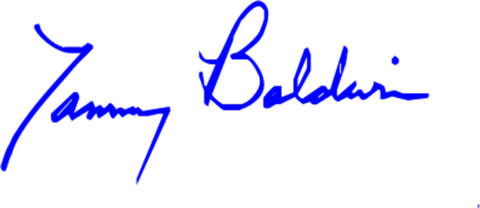
Appropriations Subcommittee on Labor, Health and Human Services, Education, and Related Agencies



Bernard Sanders United States Senator

Ranking Member, Committee on Health, Education, Labor, and Pensions
Charles E. Schumer United States Senator


Andy Kim
United States Senator
Lisa Blunt Rochester United States Senator



Tina Smith
United States Senator
Jack Reed

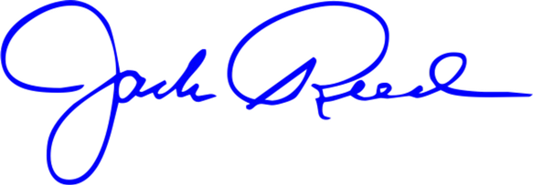
United States Senator


Richard Blumenthal United States Senator
Mazie K. Hirono United States Senator

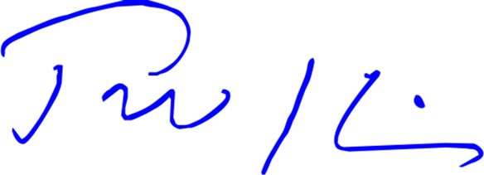
Tim Kaine
United States Senator
Brian Schatz
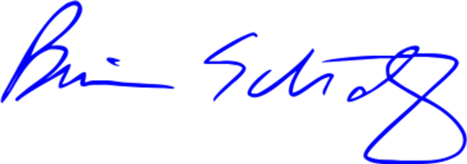
United States Senator



Cory A. Booker
United States Senator
Edward J. Markey
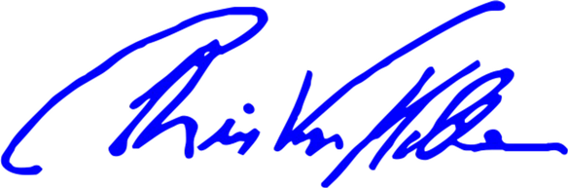
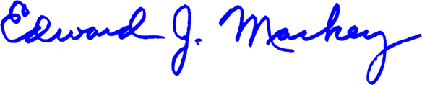
United States Senator

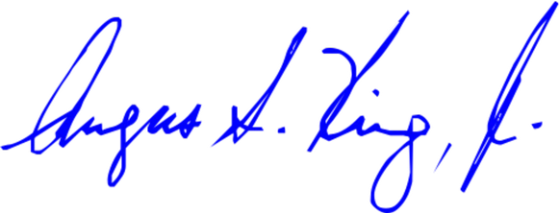
Angus S. King, Jr. United States Senator
Chris Van Hollen United States Senator




Adam B. Schiff
United States Senator
Michael F. Bennet
United States Senator




Amy Klobuchar United States Senator
Angela D. Alsobrooks United States Senator



Kirsten Gillibrand
United States Senator
Jeffrey A. Merkley


United States Senator

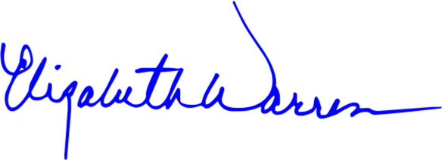
Elizabeth Warren United States Senator
Ben Ray Luján United States Senator



Raphael Warnock
United States Senator
Ron Wyden
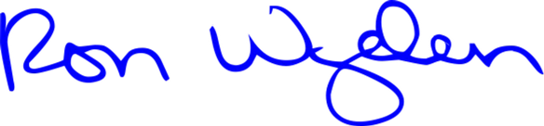
United States Senator



Richard J. Durbin
United States Senator
Christopher A. Coons

United States Senator

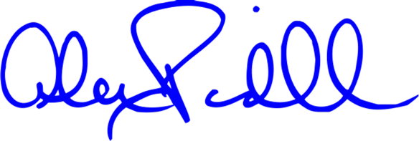
Alex Padilla
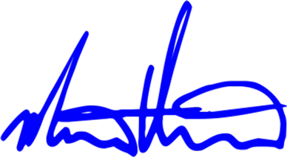
United States Senator
John Fetterman United States Senator

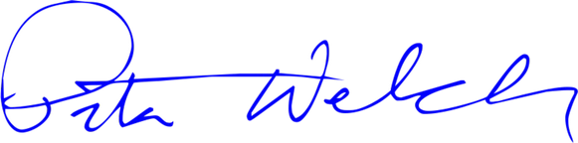
Peter Welch
United States Senator
Martin Heinrich United States Senator



Mark R. Warner
United States Senator
Tammy Duckworth
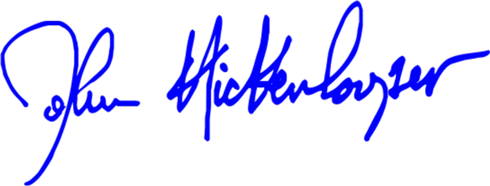

United States Senator

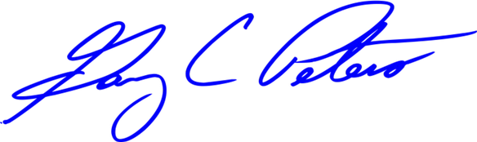
Gary C. Peters United States Senator
John Hickenlooper United States Senator

