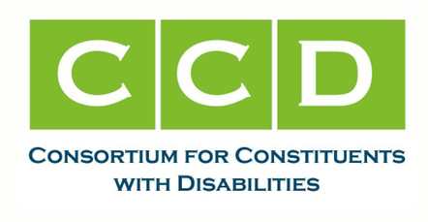

November 20, 2025

(Washington, DC) –The Consortium for Constituents with Disabilities Education Task Force stands firm in our opposition to this week’s action that unlawfully transfers authority from the U.S. Department of Education (Department) to other federal agencies. We do not support the undertaking because only the Department holds the specific authority from Congress and the expertise to support key programs that provide a necessary ecosystem to improve and support access to education for students with disabilities.

Because most students with disabilities spend all or most of their school day in general education, Congress has worked in a bipartisan fashion for decades, with support from our community of stakeholders, to infuse, integrate, and align the nation’s K-16 laws. These include: the Individuals with Disabilities Education Act (IDEA), the Elementary and Secondary Education Act (ESEA), the Carl D. Perkins Act, the Workforce Innovation and Opportunity Act and the Higher Education Act. These laws and their programs are authorized and funded so that the federal research, practice, technical assistance, educator and specialized personnel preparation, and other components of the state and district education systems ensure students with disabilities are general education students with the same access to early intervention, preK-16 education, career training, and employment as their peers.

Both the Department’s actions to break ESEA and other laws away from IDEA and Rehabilitative Services, along with their words regarding disabled students demonstrate their intention to further silo and segregate our children and their educators from the very system and support they need to have an equitable access to an education. We call on Congress to take definitive action to protect all children with disabilities, including conducting oversight hearings of executive violations of statutory requirements under all federal education laws.

CCD Education Task Force Co-Chairs:
Delancy Allred
Autism Society
dallred@autismsociety.org
In
Stephanie Flynt McEben
National Disability Rights Network (NDRN)
stephanie.mceben@ndrn.org

Laura Kaloi
Council of Parent Attorneys and Advocates and Center for Learner Equity
lkaloi@stridepolicy.com

Lindsay Kubatzky
National Center for Learning Disabilities
lkubatzky@ncld.org

Robyn Linscott
The Arc of the United States
linscott@thearc.org

The Consortium for Constituents with Disabilities (CCD) is the largest coalition of national organizations advocating together for federal public policy that ensures the self-determination, independence, empowerment, integration and inclusion of children and adults with disabilities in all aspects of society. The Education Task Force of CCD monitors federal legislation and regulations that address the educational needs of children and youth with disabilities and their families, including under the Individuals with Disabilities Education Act (IDEA), the Every Student Succeeds Act (ESSA), Section 504 of the Rehabilitation Act of 1973, and the Americans with Disabilities Act (ADA).
www.c-c-d.org

