Setback for push to get more transparency in warning public about dangerous products

by ANGIE MORESCHI & NATHAN AARON | Spotlight on America
Mon, October 6th 2025 at 12:16 PM
Updated Mon, October 6th 2025 at 12:16 PM


auto640x360, 1041kbps854x480, 1241kbps1280x720, 3511kbps
0.25x0.5xnormal1.5x2x

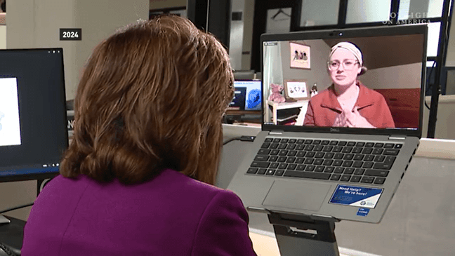

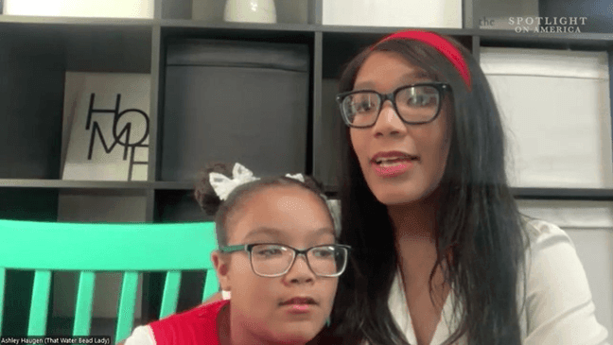

11
VIEW ALL PHOTOS
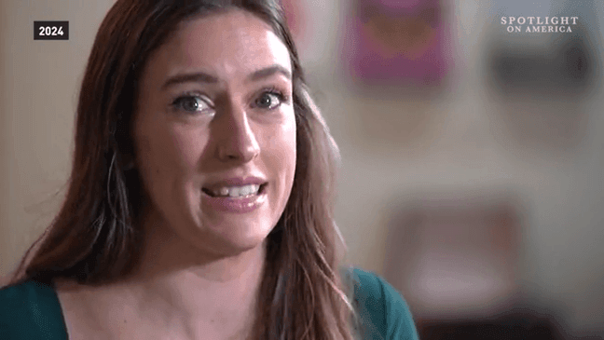

These are the faces of children who died or were injured when product recalls were delayed. (SOA graphic)

TOPICS:

WASHINGTON (SOA) — Major changes at the federal agency tasked with protecting the public from dangerous products are raising concerns about transparency.
Two proposed new rules that would have lifted some of the secrecy behind product recalls were recently withdrawn, after a shake-up at the Consumer Product Safety Commission. Spotlight on America Correspondent Angie Moreschi investigates the recent move that consumer advocates fear could leave citizens at greater risk.
auto640x360, 1041kbps854x480, 1241kbps1280x720, 3511kbps
0.25x0.5xnormal1.5x2x
SOA Correspondent Angie Moreschi reports on a setback for transparency concerns for product recalls. (SOA)
Changes to “Gag Rule” withdrawn
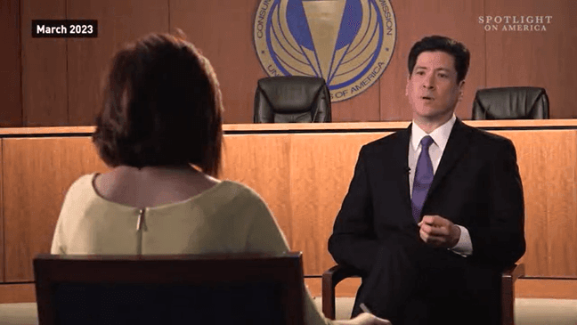
Former CPSC Chairman Alex Hoehn-Saric being interviewed by Spotlight in 2023. (SOA)
For nearly three years, Spotlight on America has investigated why it can often take years for a product to be recalled, even after the government agency tasked with protecting consumers knows it’s harming American citizens.
The former head of the Consumer Product Safety Commission Alex Hoehn-Saric made a startling admission in 2023, telling Spotlight, “If I knew a product were killing people I couldn’t tell you.”
He blamed Section 6(b) of the Consumer Product Safety Act, often called the “gag rule.” The law limits the commission’s ability to warn the public about a dangerous product without first getting consent from the manufacturer.
“It is a hindrance to the public and public safety,” Hoehn-Saric told us.
At the time, the commission initiated an update to its interpretation of 6(b), which promised to lift some of the secrecy, but after more than two years of work on that proposed rule, this August, it was among several proposed new rules withdrawn.
Shake-up at CPSC leads to change
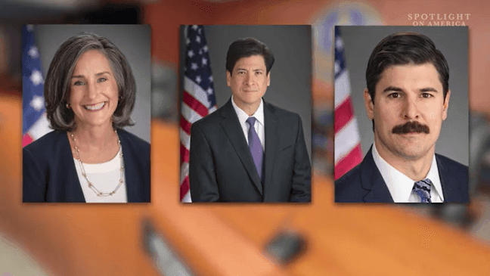
Trump administration fired the three democratic commissioners on the CPSC. (Courtesy CPSC)
The moves come after a shake-up at the CPSC, where the Trump administration fired the three democratic commissioners. With the recent resignation of Republican commissioner Douglas Dziak, that leaves just one man left making decisions about product safety, Acting Chairman Peter Feldman, who is a Republican.
“Even as leadership changes, continuity of operations remains paramount,” Feldman told a virtual audience during the CPSC 2026 Fiscal Priorities Hearing.
He said the commission remains “committed to keeping American families safe,” but in his comments, did not address the recent withdrawal of rulemaking for Rule 6(b) introduced in 2023.
Feldman won’t agree to do an interview with Spotlight, despite repeated requests, but a commission spokesperson answered our question in an email when we asked why 6(b) was withdrawn, saying:
“Please see the FR (Federal Register) notice of the termination, which sets forward the Commission’s rationale. Notably, this proposed rule has remained dormant for several years and the Commission does not view section 6(b) as a bar to public disclosure of information about product-specific issues. To date this year, CPSC has issued a record 82 unilateral safety warnings, proving once again that 6(b) is not a bar to such public warnings.”
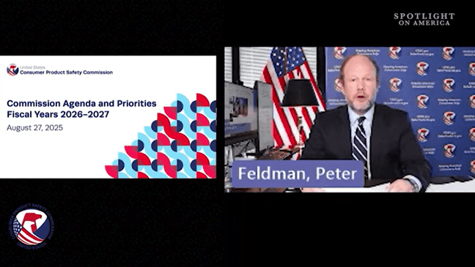
Acting CPSC Chairman Peter Feldman is the only commissioner left making decisions on product safety. (Courtesy CPSC)
In past statements, Feldman disputed that 6(b) should be called a “gag rule” and highlighted the need to be fair to industry.
“The law provides due process for a firm to seek revisions of what it believes to be erroneous information. Nevertheless, the Commission is under no obligation to make edits if it disagrees. More importantly, 6(b) allows the Commission to expedite this review and publish its warning in as little as 24 hours if it finds public health and safety requires it,” Feldman wrote in a statement posted on the CPSC website in August of 2023.
Still, as Spotlight on America has reported over the past several years, recall announcements are often delayed by months, even years, while the CPSC engages in negotiations over a proposed recall with the manufacturer. These include cases like the Fisher-Price Rock n Play, which was linked to at least 100 deaths; the Peloton Tread and Tread+ linked to one child’s death and at least 70 injuries; and several Ikea Malm Dressers linked to at least eight children who were killed.
Safety advocates criticize lack of transparency
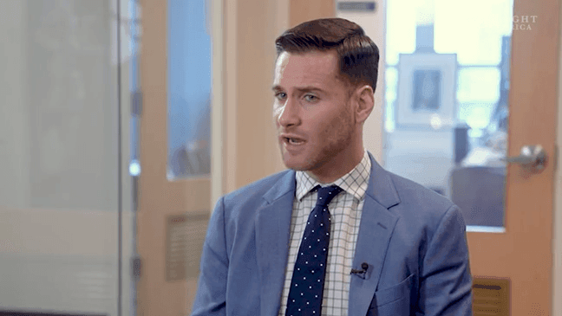
Daniel Greene with the National Consumers League is concerned about transparency in announcing product recalls. (SOA)
Consumer advocates criticize 6(b) for leading to lengthy negotiations with companies, rather than promptly warning the public about serious potential danger.
Senior Director of Consumer Protection & Product Safety at the National Consumers League, Daniel Greene, says the rule puts a muzzle on the commission, creating unreasonable delays in warning the public, while citizens– often children– continue to suffer harm.
“I’m very concerned,” Greene told Spotlight. “It’s pretty startling that the CPSC could have this really vital safety information and not be able to provide it to the American people.”
He is worried that the move to drop the Rule 6(b) update leaves consumers at greater risk.
“It makes no sense, because ultimately it was going to save lives and prevent injuries,” he said.
Florida mom Sara Gent called for more transparency in recalls in 2024 after her son was injured by water beads. (SOA)
In the meantime, another rule that focused on transparency was also withdrawn in August. It was designed to expose conflicts of interest by requiring those who submit comments or testify before the commission to disclose “financial interests and sources of funding and other contributions.”
Parent advocate calls for bipartisanship
Texas mom Ashley Haugen among several who've pushed for more transparency in announcing product recalls. (SOA)
Ashley Haugen is among several parents who have pushed for more transparency after their children were harmed when product recalls were delayed.
“I think that the most important thing that they can do is be transparent,” Haugen told Spotlight.
Ashley became a safety advocate and founded the website That Water Bead Lady after her daughter Kipley, now 9 years old, was seriously injured after accidentally swallowing water beads as a toddler.
The tiny polymer beads grow into squishy balls when liquid is added, and as Spotlight has reported have caused multiple injuries and deaths among small children who can suffer intestinal blockages and even toxic brain damage when they are ingested. The CPSC knew for years that water beads in toy products were causing serious harm to children before issuing a warning and recall.
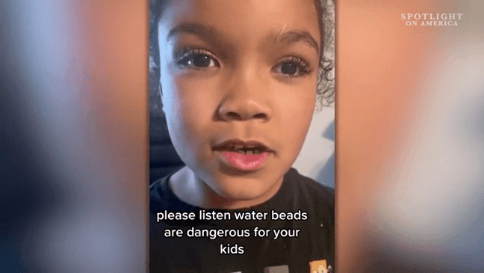
Kipley warns the public on social media about the dangers of water beads after she was injured as a toddler. (Courtesy Ashley Haugen)
Now, Ashley has mixed emotions on all the recent changes at the CPSC, because while Rule 6(b) and financial disclosures were rejected, another rule she fought hard for to regulate water beads was finalized in August.
“I just want kids to be safe,” Ashley said, expressing gratitude to Acting Chairman Feldman for passing the water beads rule, after it had been in limbo for the past year. “It's going to protect a lot of children, and I’m thankful for that.”
At the same time, she is disappointed to see fights over product safety break down over political lines, given that the Democratic commissioners were all fired.
“Product safety is a bipartisan issue. It doesn't matter if you are a democrat, a republican, or an independent, your child can be harmed by an unsafe product,” she said.
CPSC Future
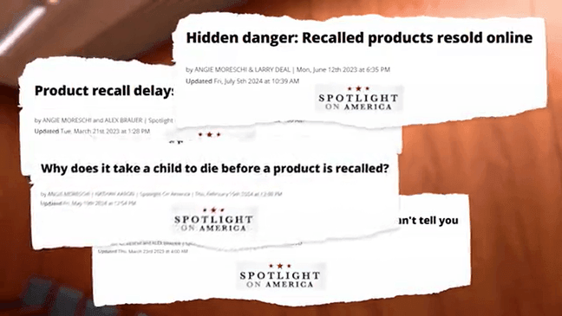
Spotlight has reported for several years about concern over transparency in product recalls. (SOA)
Consumer advocates are also worried the Trump administration is planning to eliminate the CPSC as an independent, bipartisan agency and transfer its function to the Department of Health and Human Services.
The proposed reorganization was part of the President’s 2026 budget request, but it would require an act of Congress, and it’s not clear there would be enough support.
Spotlight on America will be watching closely and report any developments.

