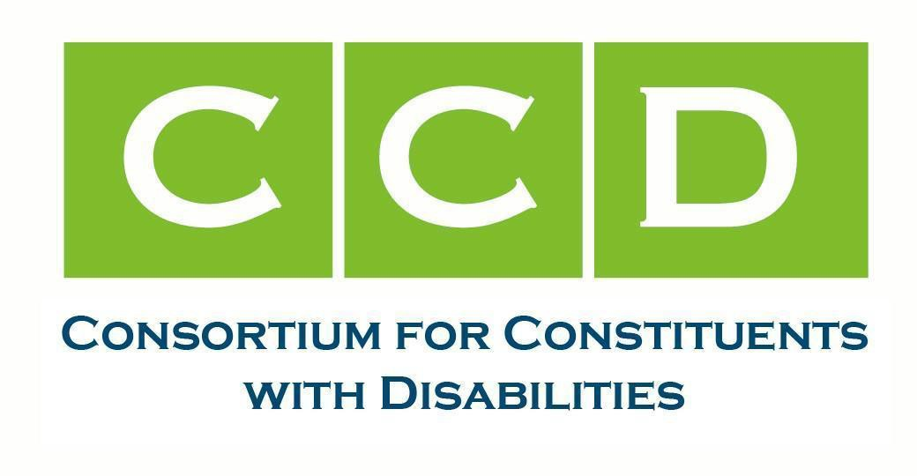

September 29, 2025

Linda McMahon  Secretary  U.S. Department of Education 400 Maryland Ave., SW Washington, DC 20202 | Hayley Sanon  Acting Assistant Secretary  Office of Elementary and Secondary Education 400 Maryland Ave., SW  Washington, DC 20202

RE: The Importance of State Assessments and Strong Accountability for Students with Disabilities Dear Secretary McMahon and Acting Assistant Secretary Sanon:
The undersigned members of the Consortium for Constituents with Disabilities (CCD) Education Task Force write regarding the potential requests from states to the U.S. Department of Education (USED) to waive the statutory requirements of the Elementary and Secondary Education Act (ESEA), currently the Every Student Succeeds Act (ESSA).

The Education Task Force monitors and advocates for federal legislation and regulations that address the educational needs of children and youth with disabilities and their families, including policy efforts under federal laws such as the Individuals with Disabilities Education Act (IDEA), ESSA, Section 504 of the Rehabilitation Act of 1973 (Section 504), the Americans with Disabilities Act (ADA) and more. We advocate for high expectations for children with disabilities under these and other laws. With this mission in mind, as well as the advocacy we conduct on behalf of the 8 million children with disabilities ages 0-21 -identified under IDEA- and the 1.5 million children eligible under Section 504, we ask that USED deny any current or forthcoming state or district requests to waive accountability and assessment requirements and/or block grant federal education funds. We also request that USED advise state agencies that they must continue to adhere to all statutory and regulatory provisions of ESSA, including those that intersect with IDEA and other federal statutes.

In 2015, ESSA’s provisions were carefully negotiated and because of bipartisan agreement, the Secretary is prohibited, by law, from waiving ten fundamental provisions of ESSA–including the formulas and distribution rules for Title funds, the rules defining Title I schools and serving them in rank order, other key fiscal requirements, statewide K-12 accountability and assessment requirements, and civil rights protections.
Additionally, block granting formula funds requires an act of Congress.

It is imperative that ESSA funds and their statutory requirements remain intact, including that states develop and maintain an accountability plan benchmarked against their own academic standards; determine teacher certification requirements; set graduation requirements; and develop and administer statewide assessments for students in reading and mathematics (in grades 3-8 and once in high school) and by grade band for science. The federal government is not involved in these decisions, and states have the authority, autonomy, and flexibility to support districts so that students can meet academic standards. ESSA limits the use of an alternate assessment aligned with alternate academic achievement standards (AA-AAAS) to no more than 1% of all students, specifically those with the most significant cognitive disabilities. CCD remains concerned that many states remain out of compliance with the one percent cap, resulting in thousands of students with disabilities being inappropriately assigned to the AA-AAAS.
We also would like to point out that the Secretary cannot waive applicable civil rights requirements. Given the roots of ESEA as a civil rights law and ED’s long-standing focus on equal access to education, bipartisan agreement by Congress in 2015 affirmed that these fundamental civil rights requirements and protections cannot be unilaterally waived by the Secretary of Education.
We are further concerned that states could argue that vouchers or school choice programs would better serve students with disabilities, and block granting funds could enable the use of federal funds for private school tuition. CCD does not support the use of any Federal education funds (e.g., ESEA Title programs, IDEA Parts B, C, D) for block grants or for school choice programs, and current law does not enable ESEA or IDEA funds to be used for such purposes. Private schools are not required to accept students with disabilities nor abide by the requirements of the IDEA, which places our children at great risk of losing their educational access, rights, and opportunities under the law. Currently, only 1.8% of students with disabilities (144,000) served under IDEA are parentally placed in private schools (IDEA Section 618 data products) and we know for some, they are forced to return to their public school district when their private school becomes too expensive, refuses to provide necessary services, therapies and supports, doesn’t have transportation, and/or the family’s circumstances change (National Council on Disability – Choice and Vouchers: Implications for Students with Disabilities).
CCD reiterates our strong plea for you to deny any waivers that do not abide by the following principles:
- States must be required to administer annual state assessments that include students with disabilities.
- States must adhere to the ESSA requirement to assess not less than 95 percent of all students, including not less than 95 percent of students with disabilities at their enrolled grade level. Notably, the IDEA requires states to assess 100 percent of students with disabilities on state and district assessments.
- The results of state assessments must be used to determine which schools are in need of improvement so ESSA funds can support underperforming student subgroups, such as students with disabilities.
- The administration of state assessments should not preclude districts from administering formative or interim assessments to monitor student progress and inform instruction.

- ED should provide states with ongoing, comprehensive technical assistance to support the administration of assessments and provision of accommodations, assistive technology, devices, services and other supports required to fully include students with disabilities.
- States seeking to amend their state plan must detail how they will improve conditions for learning and what specific steps will be taken to support students who are struggling, such as those with disabilities.

USED should continue to ensure ESSA is implemented by statute and its funds are used as required by federal law. Any action to subvert federal law through waivers that illegally promote or support the block granting of ESSA funds would have lasting negative impacts on students, families, educators, and the future of millions of children with disabilities.

The 24 undersigned organizations stand united with the children, families, educators, specialized personnel, researchers, and others and will continue to fight for the hard-won access to education and the civil rights of children with disabilities. Together with bipartisan allies in Congress and across the U.S., we will work to protect access to education through IDEA, Section 504, and ESSA as each provides distinct civil and educational rights and opportunities in America’s schools. We ask you to stand firm in your commitment to these children and their families.

Sincerely,

Access Ready, Inc. Allies for Independence
American Music Therapy Association American Therapeutic Recreation Association
Association of University Centers on Disabilities Autism Society of America
Autistic Women & Nonbinary Network
Children and Adults with Attention-Deficit/Hyperactivity Disorder CommunicationFIRST
Council for Learning Disabilities
Council of Parent Attorneys and Advocates Disability Belongs
Division for Learning Disabilities of the Council for Exceptional Children (DLD) Learning Disabilities Association of America
Muscular Dystrophy Association
National Association of Councils on Developmental Disabilities National Association of School Psychologists
National Center for Learning Disabilities National Disability Rights Network (NDRN) School Social Work Association of America SPAN Parent Advocacy Network (SPAN)

TDIforAccess
The Arc of the United States The Center for Learner Equity

cc: Diana Diaz, Assistant Secretary (Acting), Office of Special Education and Rehabilitative Services

For questions or additional information please contact: CCD Education Task Force co-chairs:

Delancy Allred  dallred@autismsociety.org Autism Society of America | Stephanie Flynt  Stephanie.flynt@ndrn.org National Disability Rights Network | Robyn Linscott  linscott@thearc.org  The Arc of the United States
Laura Kaloi lkaloi@stridepolicy.com  Assistive Technology Industry Association, Council of Parent Attorneys and Advocates &  the Center for Learner Equity | Lindsay Kubatzky lkubatzky@ncld.org  National Center for Learning Disabilities

The CCD Education Task Force leads, advocates for, and monitors federal legislation and regulations that address the educational needs of children and youth with disabilities and their families, including policy efforts affecting the funding and implementation of federal laws such as IDEA, Every Student Succeeds Act (ESSA), Section 504, and the Americans with Disabilities Act (ADA). We advocate for high expectations for children with disabilities under these and other laws.

