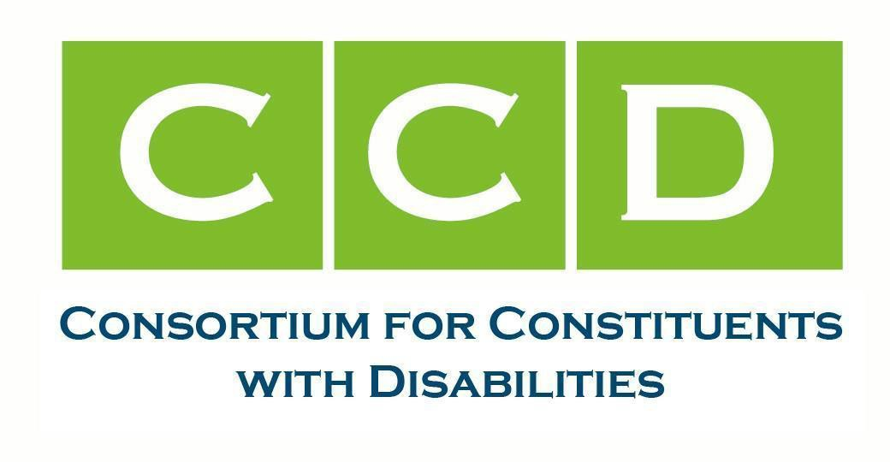
October 9, 2025

Ms. Linda McMahon Secretary of Education
U.S. Department of Education 400 Maryland Ave., SW Washington, DC 20202

RE: The Use of the Phrase “Special Needs” in Official U.S. Department of Education Communications

Dear Secretary McMahon:

The undersigned members of the Consortium for Constituents with Disabilities (CCD) Education Task Force write regarding the use of the phrase “Special Needs” in official U.S. Department of Education (USED) communications. The Education Task Force monitors and advocates for federal legislation and regulations that address the educational needs of children and youth with disabilities and their families, including policy efforts under federal laws such as the Individuals with Disabilities Education Act (IDEA), ESSA, Section 504 of the Rehabilitation Act of 1973 (Section 504), the Americans with Disabilities Act (ADA) and more. We advocate for high expectations for children with disabilities under these and other laws. With this mission in mind, as well as the advocacy we conduct on behalf of the 8 million children with disabilities ages 0-21 -identified under IDEA- and the 1.5 million children eligible under Section 504, we ask that you discontinue the use of this harmful and stigmatizing phrase.

As noted by the National Center on Journalism and Disability (NCDJ), “the word ‘special’ in relationship to those with disabilities is now widely considered offensive because it euphemistically stigmatizes that which is different.” The NCDJ therefore recommends avoiding using this term when describing a person with a disability. In addition, the Associated Press Stylebook also advises to avoid this and related terms when possible as “many view them as euphemistic and offensive”. The National Disability Rights Network and The Arc of the United States also state on their respective websites that this term should not be used.¹² There is even research to suggest the harmful impact

¹ National Disability Rights Network. (2020, October 27). Communicating About People with Disabilities. NDRN. https://www.ndrn.org/resource/communicating-about-people-with-disabilities/
² The Arc. (2025, July 14). Press center. The Arc. https://thearc.org/about-us/press-center

of using these two words together. A 2016 study found that “persons are viewed more negatively when described as having special needs than when described as having a disability or having a certain disability, indicating that special needs is an ineffective euphemism.”³ Instead, we urge USED to use the phrases children/students with disabilities or disabled children/students.

The 24 undersigned organizations stand united with the children, families, educators, specialized personnel, researchers, and others and will continue to fight for the hard-won access to education and the civil rights of disabled students. Together with bipartisan allies in Congress and across the U.S., we will continue our work to protect access to education through IDEA, Section 504, and ESSA as each provides distinct civil and educational rights and opportunities in America’s schools. We ask you to stand firm in your commitment to these children and their families by eliminating the use of this harmful phrase which only serves to perpetuate presumptuous stigma and low expectations of students with disabilities. We’d welcome the opportunity to meet with you to discuss language regarding individuals with disabilities.

Sincerely,

Access Ready, Inc.
American Music Therapy Association American Therapeutic Recreation Association Assistive Technology Industry Association
Association of Assistive Technology Act Programs Association of University Centers on Disabilities Autism Society of America
Children and Adults with Attention-Deficit/Hyperactivity Disorder Council for Learning Disabilities
Council of Parent Attorneys and Advocates Disability Rights Education & Defense Fund
Division for Early Childhood of the Council for Exceptional Children (DEC) Division for Learning Disabilities of the Council for Exceptional Children (DLD) Muscular Dystrophy Association
National Association of Councils on Developmental Disabilities National Center for Learning Disabilities
National Disability Rights Network (NDRN) National PLACE
Perkins School for the Blind

³ Gernsbacher, M. A., Raimond, A. R., Balinghasay, M. T., & Boston, J. S. (2016). “Special needs” is an ineffective euphemism.
Cognitive research: principles and implications, 1(1), 29.

TASH
TDIforAccess
The Advocacy Institute
The Arc of the United States The Center for Learner Equity

cc: Diana Diaz, Assistant Secretary (Acting), Office of Special Education and Rehabilitative Services cc: David Cantrell, Deputy Director, Office of Special Education Programs
cc: Rachel Oglesby, Chief of Staff, U.S. Department of Education
For questions or additional information please contact: CCD Education Task Force co-chairs:

Delancy Allred  dallred@autismsociety.org Autism Society of America | Stephanie Flynt  Stephanie.flynt@ndrn.org National Disability Rights Network | Robyn Linscott  linscott@thearc.org  The Arc of the United States
Laura Kaloi lkaloi@stridepolicy.com  Assistive Technology Industry Association, Council of Parent Attorneys and Advocates &  the Center for Learner Equity | Lindsay Kubatzky lkubatzky@ncld.org  National Center for Learning Disabilities

The CCD Education Task Force leads, advocates for, and monitors federal legislation and regulations that address the educational needs of children and youth with disabilities and their families, including policy efforts affecting the funding and implementation of federal laws such as IDEA, Every Student Succeeds Act (ESSA), Section 504, and the Americans with Disabilities Act (ADA). We advocate for high expectations for children with disabilities under these and other laws.

