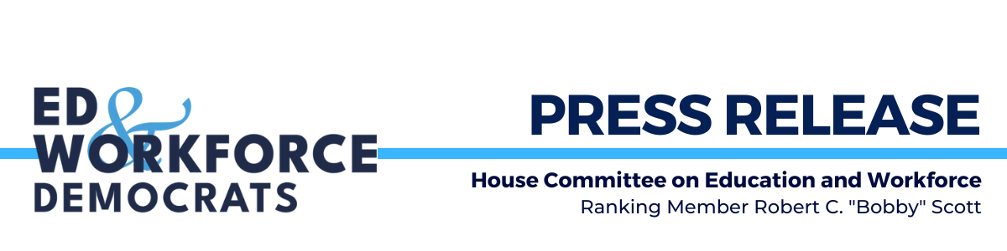FOR IMMEDIATE RELEASE
August 27, 2025

Contact: Democratic Press Office, 202-226-0853

Ranking Member Scott Releases New Report on Trump Administration’s Attacks on Disability Community

WASHINGTON – Today, Ranking Member Robert C. “Bobby” Scott (VA-03), House Committee on Education and Workforce, released a new report entitled “Living Independently, Participating Fully: Defending Against the Trump Administration's Attacks on People with Disabilities.” The report outlines how the Trump Administration’s proposed elimination of the Administration for Community Living (ACL), deep Medicaid cuts, and rollback of equity protections threaten the independence and well-being of people with disabilities and older adults.

The report shows how these actions are part of a broader pattern from the Trump Administration undermining programs that empower and support individuals with disabilities and older adults. The report also details how historic Medicaid cuts, threats to the direct care workforce, and rollbacks of diversity, equity, inclusion, and accessibility (DEIA) initiatives, jeopardize the health and independence of millions. Finally, the report raises concerns about how mass layoffs, reduced services, and weakened legal protections are putting millions at risk.

The loss of ACL as a centralized, disability-focused federal agency is not merely a bureaucratic reallocation. It is an assault on the rights and safety of disabled people and older adults across this country. “After more than 50 years of progress during both Republican and Democratic administrations toward greater autonomy, independent living, and equal economic opportunity for people with disabilities, dismantling ACL threatens to move this country backwards,” said Ranking Member Scott.

House Democrats will continue to fight for accountability and stand up for the civil rights and dignity of all Americans, regardless of age or ability.

To read the full report, click here.

###

democrats-edworkforce.house.gov
X – YouTube – Flickr – Facebook – Instagram– Bluesky

