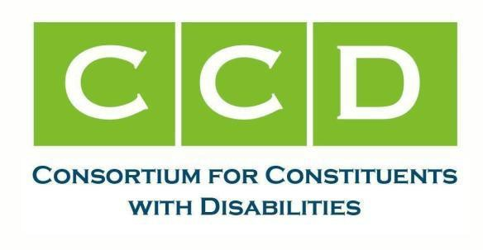
Submitted via regulations.gov

July 30, 2025

Michael Hollar, Senior Economist
Office of Policy Development and Research
U.S. Department of Housing and Urban Development 451 7th Street, SW
Washington, D.C. 20410

RE: 60-Day Notice of Proposed Information Collection: Statutorily-Mandated Collection of Information of Tenants in LIHTC Properties; OMB Control No.:2528-0230

Thank you for the opportunity to comment on the “60-Day Notice of Proposed Information Collection: Statutorily-Mandated Collection of Information of Tenants in LIHTC Properties; OMB Control No.:2528- 0230” (FR-7103-N-02). The undersigned are co-chairs of the Consortium for Constituents with Disabilities (CCD) Housing Task Force. CCD is the largest coalition of national organizations working together to advocate for federal public policy that ensures the self-determination, independence, empowerment, integration, and inclusion of children and adults with disabilities in all aspects of a society free from racism, ableism, sexism, and xenophobia, as well as LGBTQ+ discrimination and religious intolerance. The Housing Task Force works to ensure that all people with disabilities have safe, stable, accessible, affordable, and integrated housing that enables people to live in communities of their choosing, with full access to home and community-based services and supports.

Whether the proposed collection of information is necessary for the proper performance of the functions of the agency, including whether the information will have practical utility

People with disabilities and their families, particularly those with low incomes, face a national shortage of accessible and affordable housing.¹ People with disabilities often have few financial resources, remain among the country’s lowest-income households, and far too frequently encounter discrimination when trying to seek or maintain housing.² The LIHTC program, including but not limited to properties that receive Section 811 project based rental assistance, provide a critical source of affordable, accessible housing. CCD notes that LIHTC requirements promote new construction and substantial rehabilitation, making this one of the few reliable sources of accessible housing constructed under federal fair housing requirements. Collecting data on utilization by people with disabilities is critical to ensuring equal access to this important resource.

1 See, e.g., U.S. Dept. Of Housing and Urban Development, “Worst Case Housing Needs: 2023 Report to Congress” (2023) at https://www.huduser.gov/portal/publications/Worst-Case-Housing-Needs-2023.html.

2 National Fair Housing Alliance, “2024 Fair Housing Trends Report” at https://nationalfairhousing.org/resource/2024-fair- housing-trends-report; U.S. Dept. of Housing and Urban Development, “Rental Housing Discrimination on the Basis of Mental Disabilities: Results of Pilot Testing,” (2017) at https://www.huduser.gov/portal/publications/MentalDisabilities-FinalPaper.html.

Ways to enhance the quality, utility and clarity of the information to be collection

Both forms HUD-52695 and HUD-52697 pre-date HUD’s implementation of the Section 811 Project Rental Assistance (PRA) program and therefore do not include PRA in the list of rental assistance that may be attached to the LIHTC units. The vast majority of HUD’s PRA Federal rental assistance is in LIHTC projects.

CCD proposes the following revisions:

Form HUD-52697

  - Include S. 811 PRA as a Source of Federal Rental Assistance under Part VI Monthly Rent.

  - Add the following questions:

Is the tenant residing in a unit that is designed to be (check all that apply)
Accessible to a person with hearing/visual disabilities
Accessible to a person with physical disabilities
Accessible to a person who uses a wheelchair
None of the above

If any of the above boxes are checked, does any member of the tenant household require the access features of the unit?
Yes
No

Form HUD-52695

  - Revise “If “Federal”, Section 8 Contract Number” on page 1 to: “If Federal, provide contract number”. The S. 811 PRA program is Federal rental assistance but the contract number is not specifically a “Section 8” contract number.

Thank you for this opportunity to comment on HUD forms 52697 and 52695. Sincerely,
Allie Cannington, The Kelsey
Co-Chair, CCD Housing Task Force allie@thekelsey.org

Jennifer Kye, Justice in Aging
Co-Chair, CCD Housing Task Force jkye@justiceinaging.org

Greg Robinson, Autistic Self Advocacy Network Co-Chair, CCD Housing Task Force grobinson@autisticadvocacy.org

