President’s FY26 Budget Request

($ in billions) | FY25 | FY26 | Percent change
Base discretionary - Defense | $892.6 | $1,011.9 | +13.4%
Base discretionary - Non-defense | $720.5 | $601.2 | -16.6%
Defense | $848.3 | $961.6 | +13.4%
Homeland Security | $65.1 | $107.4 | +64.9%
Education | $78.7 | $66.7 | -15.3%
Labor | $13.3 | $8.6 | -34.9%
↳ Office of Federal Contract Compliance Programs | $0.1 | Eliminated | -100%
↳ Office of Disability Employment Policy | $43 million | $34 million
Veterans Affairs | $129.2 | $134.6 | +4.1%
General Services Administration | -$0.9 | $0.5 | N/A
NASA | $24.8 | $18.8 | -24.3%
Small Business Administration | $0.9 | $0.6 | -33.2%
Social Security Administration | $12.7 | $12.7 | flat
HHS (includes CMS) | $127 | $93.8 | -26.2%

President’s FY26 Budget Request

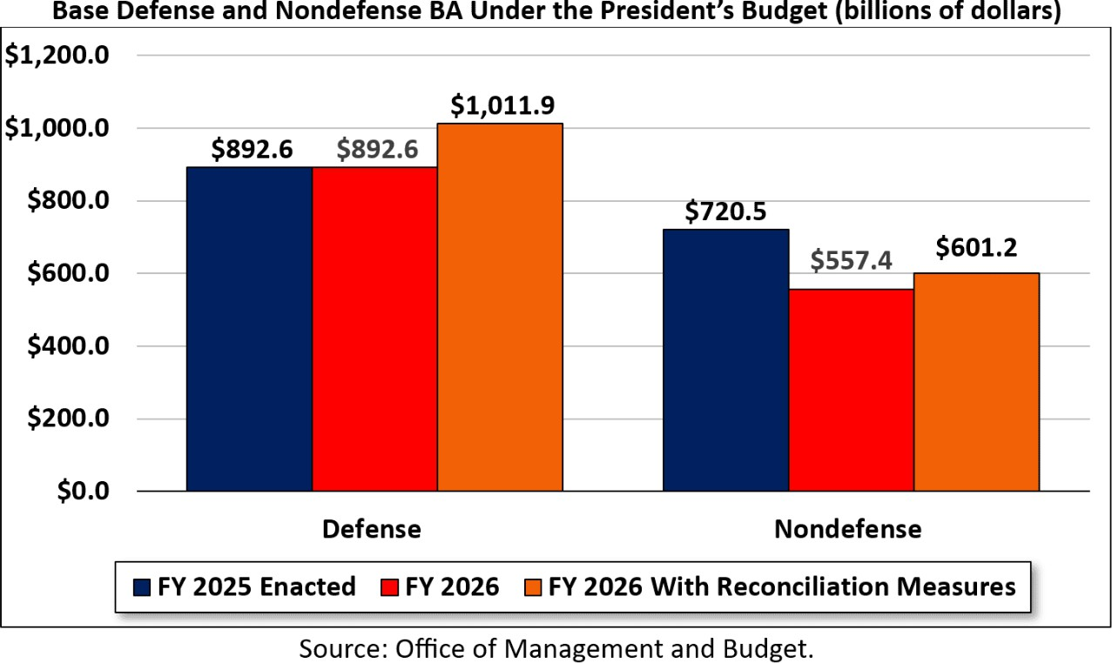

Byrd Bath – Provisions removed
- Changes to Federal Employees Retirement System contributions
- State authorization to conduct border security and immigration enforcement
- Limitation of court contempt powers to restrain preliminary injunctions and temporary restraining orders
- Barring noncitizens and permanent residents from receiving SNAP
- Extension of the suspension of permanent price authority
- Funding cap on the Consumer Financial Protection Bureau
- Authorization of the sale of millions of acres of public land
- Easing offshore oil and gas project compliance
- Requiring USPS to sell their electric vehicles
- Repealing an EPA rule limiting air pollution from passenger vehicles
- Permitting project developers to bypass judicial environmental reviews
- Increasing congressional power over more impactful regulations
- Medicaid:
  - Limiting states’ use of provider taxes in financing their portions of Medicaid
  - Limiting noncitizen participation in Medicaid by lowering federal Medicaid funding for expansion states covering noncitizens using state funds
  - Repealing funding for gender affirming care under Medicaid
  - Under consideration: Prohibiting Medicaid payments to Planned Parenthood

