Disability Community Briefing: Defending Students with Disabilities in the Age of Trump

June 5, 2025

1


Welcome!
Disability Community Briefing
Defending students from the current Administration’s attacks on students and the Department of Education

Photo of Jennifer Keelan participating in Capital Crawl, taken by Tom Olin
2

Presenters
Karma Quick-Panwala (she/her), Director of Children and Family Advocacy, Disability Rights Education & Defense Fund
Catherine E. Lhamon (she/her), incoming Executive Director, Edley Center on Democracy & the Rule of Law; Previous: Assistant Secretary, OCR, Department of Education
Auden Perino (they/them), Senior Counsel for LGBTQI+ Equality, National Women’s Law Center
Santiago Orosco (he/they or él/elle), Director of Organizing, New Disabled South
Winston Berkman-Breen (he/him), Legal Director, Student Borrower Protection Center
Julea Seliavski (they/them), Co- President, National Disabled Law Students Association
Mary J. Goodwin-Oquendo (she/her), Founder and President, The Goodwin-Oquendo Law Firm; Adjunct Professor, Fordham Law School
3

Topics to Be Covered
- What is the Department of Education? Why is it important?
- What has happened to
the Department so far?
  - Staff and funding cuts
  - Removal of discipline
guidance
- What students are
particularly targeted?

- Why student loans are a disability issue
- What might happen next?
- We still have rights!
- How we make our voices heard
  - Action Alert
  - July 2025 Protests
- Questions & Answers

4

Department of Education – Core Functions for Students

Enforcement of civil rights laws
  - Laws that bar discrimination based on race, ethnicity, sex, age
and disability

Enforcement of laws that help students with disabilities
  - Section 504 of the Rehabilitation Act
  - Individuals with Disabilities Education Act (IDEA)

Research and data collection
  - Civil Rights Data Collection
5

Department of Education – Core Functions for Students (Continued)


Funding for students and schools
  - Title I and Head Start funds
  - IDEA funds

Student loans and aid, student loan repayment programs

6


Department of Education –
Staff and Funding Cuts
- March 20, 2025: Executive Order to close Department
  - This requires Congress to say yes
- Staff cut in half nationwide
  - 1,300 fired, another 600 resigned /
retired
  - Hundreds of staff cut from Office for Civil Rights (OCR) and Federal Student Aid (FSA)
  - Note: also staff cuts at Bureau of Indian Education
7

Department of Education – Staff and Funding Cuts (Continued)
- Offices closed
  - Half the field offices closed
  - 7 of 12 regional OCR offices closed, 5 left
- Complaints on hold
  - About 10,000 OCR complaint on hold
    - About 6,000 disability
  - Preference to investigations ordered by Administration
- Funds cut
  - $1 billion mental health
  - $600 million teacher training
8

Department of Education – Discipline Guidance
- April 23, 2025: Executive Order on school discipline
  - Removed 2014 guidance on discipline and race
  - Following guidance is itself discrimination
  - Discourages school districts from taking affirmative steps to
reduce disproportionate discipline, such as:
    - Positive behavior supports and interventions
    - Rewriting discipline policies re “willful defiance”
- Important: July 2022 Guidance on Discipline and Students with Disabilities is still in effect, available here: https://www.ed.gov/media/document/504-discipline-guidance-2022- 21258.pdf
9

Civil Rights of Trans and Nonbinary Students
Remember: trans & nonbinary students have civil rights at school
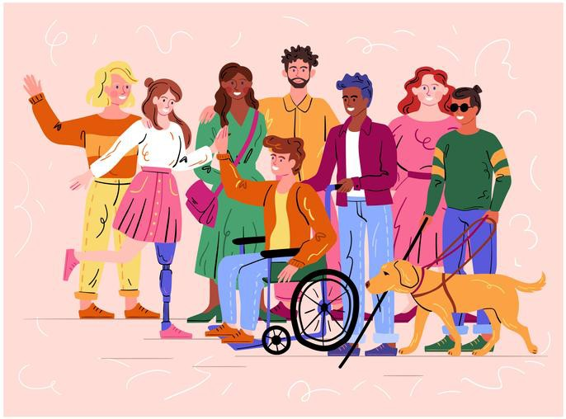
- Title IX protects students from discrimination based on sex, including stereotypes–broad remedy
- White House and Department of ED cannot undo
Title IX, limited authority delegated by Congress
- Schools still must protect students who are trans, nonbinary, and intersex
All youth, including trans and nonbinary
students, deserve:
- Opportunity to learn and grow up as truest selves
- Inclusion in every part of school ₁₀

Civil Rights of Trans and Nonbinary Students
(Continued)
Safety and opportunity at school go hand and hand for:
- LGBTQI+ students
- Black and Brown students
- Girls and women
- Disabled students
  - Many disabled students are trans and nonbinary
  - Many trans and nonbinary students have disabilities
Anti-trans school sports bans rely on sex testing and body policing
- adults inappropriately scrutinizing students’ bodies
- we know Black and brown women & girls targeted worst for body policing
Anti-trans policies attempting to enforce a narrow definition of sex
- increased policing of cisgender girls who do not conform to gender
stereotypes 11

White House Attacks on Trans & Nonbinary Students
Short version:
- Series of destructive attacks against core US institutions
- Goal: end existence of safe and inclusive public K-12 schools, eliminate equal opportunity
Tactics include:
- Weaponizing federal civil rights laws to harm LGBTQI+ and BIPOC students
- Using confusion, disinformation, and fear to target, bully, and scapegoat
trans, nonbinary, and intersex students
- Emboldening worst actors who support a bigoted, discriminatory regime
- Manufactured panic by extreme far-right

Trans and nonbinary students go to school
like every other young person. The “controversy” is fake. ₁₂

White House Attacks on Trans & Nonbinary Students
(Continued)
- Anti Trans Sports Ban Executive Order, 2/5/25
  - Pushing schools and athletic orgs to ban trans girls and women from sports
- Interfering with Curriculum Executive Order, 1/29/25
  - Pushing schools to ignore and distort race and gender in country’s history
  - Erases and harms transgender, nonbinary, and intersex students
- Anti-LGBTQI “Sex Definition” Executive Order, 1/20/25
  - Directs federal agencies to use baseless, harmful definition of “sex”
  - Effort to roll back regulations and policies protecting transgender,
nonbinary, and intersex people
Note: this material does not repeat misleading names of orders. It does not cover trans healthcare (gender affirming care) or policies involving the US military & veterans
13

Exploiting Trans Students & Fake Moral Panic

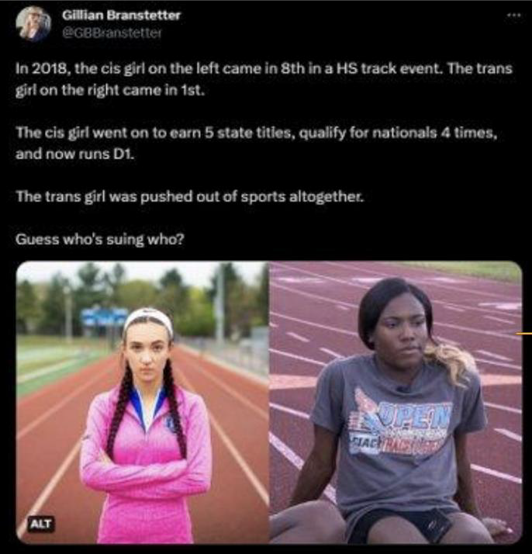
Recent history: Targeting trans students as scapegoats traces back to Soule case filed by hate group ADF
- "Historian Gillian Frank has noted the parallels between the myths about trans women making bathrooms unsafe for cis women and girls... and the racist myths pushed by segregationists stoking fears about integration's purported threat to white women's virtue and purity. The idea of protecting girls is meant to win, and with it, they can fuel a stigmatizing moral panic about trans people." - Melissa Gira Grant, The Soapbox, 2021, (link)
There is one best, evidence-supported intervention to mitigate
crisis level health risks to trans youth: social support, from even one adult. Sometimes that life sustaining adult is a coach.
14

Department of Education Actions
- January 24, 2025: ED dismisses complaints about K-12 book bans amid an unprecedented wave of state-level censorship efforts, targeting books about:
  - LGBTQIA+ people and history; racism, segregation, and colonization; reproductive rights and sexual health; sexual harassment, violence, and abuse; student civil rights
- March 28, 2025: ED guidance letter directing schools to forcibly
out (and endanger) trans and nonbinary youth
- April 4, 2025, DOJ and ED special investigation team to intimidate schools that support and include trans students in sports, restrooms, etc.
15

Other Federal Agencies Bullying Trans & Nonbinary Students
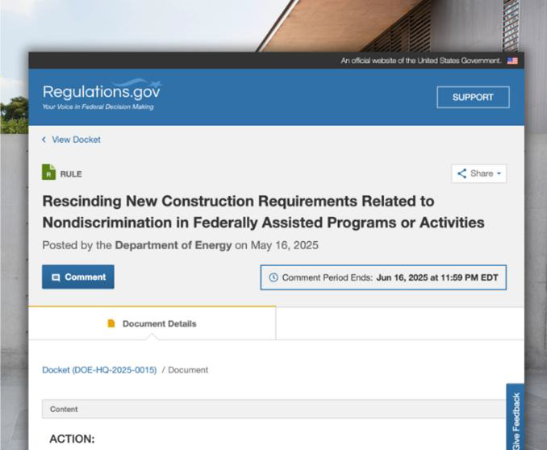
- Health & Human Services: failed attempt
to bully Maine schools
  - Settlement restored child nutrition funds
- Department of Energy (DOE)
  - Ignoring correct process
  - Targeting Title IX requirement schools allow girls to join boys’ teams if there is no team for girls, etc.
  - Note: DREDF webinar next week to comment on DOE rules
16

Department of Education – Student Loans and Assistance
Department of ED, Federal Student Aid (FSA) runs:
- Public Service Loan Forgiveness (PSLF)
- Income-Driven Repayment (IDR) Plans
- Total & Permanent Disability (TPD) Discharge
March 2025: more than 300 staff cut from FSA
Student loans are a disability issue! Disabled people, disability rights advocates, special ed teachers, nonprofit staff – we all need student loans and affordable payment plans!
17

Department of Education – Student Loans and Assistance

(Part 2)
Direct Loans
- Public Service Loan Forgiveness
  - Historically dysfunctional
IDR
  - Biden Administration took steps to fix -> +1 million debt free
Public Service Employer [30 hours]
  - New option called “BuyBack” allows borrowers to cure past ineligible payments
120 payments

18

Department of Education – Student Loans and Assistance
(Part 3)
- IDR Plans
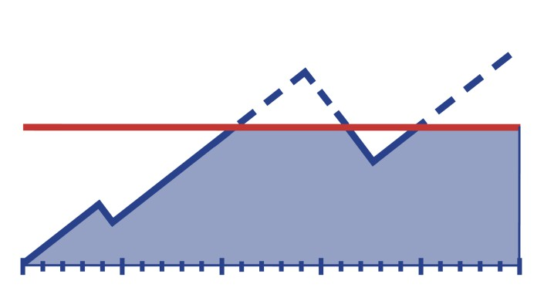
  - Affordable payments, debt cancellation
  - Biden Administration took steps to fix -> +1.4 million debt free
  - Biden introduced newest plan, SAVE Plan
19

Department of Education – Student Loans and Assistance
(Part 4)
IDR SAVE Plan
- Aug. 2023: Introduced
- Spring 2024: 18 states sue
- Feb. 2025: court blocks SAVE
  - 8 million SAVE borrowers in “forbearance” – this means no payments required, no interest, no credit toward forgiveness
- Feb. to Mar. 2025: IDR application offline, then back online after American Federation of Teachers sued
20

Department of Education – Student Loans and Assistance
(Part 5)

PSLF
  - About 50,000 BuyBack applications waiting for review
  - March EO and summer rulemaking

IDR Plans
  - About 2 million applications waiting to be processed
  - Reconciliation bill would eliminate ICR, PAYE, and SAVE plans and replace with new RAP*
  - Summer rulemaking
- No staff to help borrowers solve their problems
- SAVE litigation continues (brought by states and by
American Federation of Teachers)
21

Department of Education – What Might Happen Next
- Administration wants to:
  - move parts of ED to the Department of Health and Human Services
  - move student aid to Small Business Administration
  - eliminate Head Start
- Budget Reconciliation (huge topic):
  - “School choice” via federal voucher tax credit
    - Increased discrimination against disabled students
    - Decrease Medicaid $ for special education health services
- FY 2026 ED Budget
  - > 15% cut overall
  - $4.5 billion cuts to K-12 programs including for homeless youth
  - huge cuts to federal work-study
  - Pell grants cut from $7,395 to $5,710 22

Department of Education – What Might Happen Next
(Continued)

- Litigators are fighting back:
  - At least 7 cases filed to challenge Administration actions against Department of ED
  - District of Massachusetts granted preliminary injunction in case brought by 21 states re staff cuts
    - BUT District of D.C. denied preliminary injunction in case brought by students, parents, and COPAA re staff cuts

23

Students of Immigrant Families
- January 20, 2025: Executive Order stating that undocumented immigrants must register
- February 2025 to present: media campaign targeting undocumented immigrants, “self-deport” or face fines and imprisonment
- March 12, 2025: Department of Homeland Security (DHS) sets out
process for registration, effective April 11, 2025
Coming forward to register will be extremely dangerous for most undocumented community members. It could lead to detention, deportation, and possibly criminal prosecution.
– National Immigration Law Center
24

Students of Immigrant Families (Part 2)

- January 24, 2025: DHS directive rescinding decade- old guidance re ICE enforcement in “sensitive” areas – including schools and churches
“Criminals will no longer be able to hide in America’s schools and churches to avoid arrest.” – Benjamine Huffman, Acting Secretary, Department of Homeland Security

25

Students of Immigrant Families (Part 3)
- Impacts on millions of children in immigrant families (one in four children nationwide):
  - increased fear and stress affecting daily life
  - problems sleeping and eating
  - headaches and stomachaches
  - mental health conditions like depression and anxiety
  - decreased performance in school
  - reluctance to access programs and services
  - long-term health consequences
Source: KFF

26

Autistic and Neurodiverse Students
"Autism destroys families, and more importantly, it destroys our greatest resource, which is our children … And these are kids who will never pay taxes, they’ll never hold a job, they’ll never play baseball, they’ll never write a poem, they’ll never go out on a date. Many of them will never use a toilet unassisted.”
– Robert F. Kennedy Jr.,
United States Secretary of Health and Human Services

27

We Still Have Rights!
Laws like ADA, Section 504, and IDEA still exist!
- The White House and the Department of ED cannot change statutes
- Students can still:
  - Ask for accommodations at school
  - File a discrimination complaint with OCR, U.S. Department of Education or state/local administrative agencies
  - Participate in the IEP process
  - File a due process complaint
  - File a compliance complaint with their state department of education
  - File a case in state or federal court
  - Consult an attorney to assist with any of the above
- Don’t forget state laws – for example, CA AB 2657 (2018)
28

Make Our Voices Heard! Action Alert
- Find your elected representatives and contact them!
  - Use this tool to find your reps, https://www.usa.gov/elected-officials
- Tell your elected representatives to defend students and ED
  - You can write your own email or you can use tools by COPAA https://copaa.salsalabs.org/OpposePlanstoCloseEDProtectStudentswithDisab ilities/index.html and the Council for Exceptional Children, https://exceptionalchildren.org/lac?vvsrc=/Campaigns/121668/Respond
- And tell your reps to defend Medicaid against billions in cuts!!
  - Medicaid supports students with disabilities at school with screening, early intervention, occupational therapy, mental health counseling, specialized medical equipment, and transportation
  - Get more information on DREDF’s page, https://dredf.org/hands-off-our- medicaid/
29

Make Our Voices Heard – Protest!
- Join a disability community protest!
- June 16, 2025, Sacramento, California
  - Gather: 11 am, State Capitol, West Steps
- ADA anniversary = disability community events
  - July 21, 2025, National Council on Independent Living rally
    - Gather: 2:00 pm 11th + G Streets NW, Washington, D.C.
    - March: 3:00 pm
    - Rally: 4:00 pm US Capitol
  - Contact your state and local disability organizations and ask
about local rallies! Or organize one yourself!
    - State protection and advocacy agencies, https://www.ndrn.org/
    - Independent living centers, https://ncil.org/

30

Upcoming Webinars
Defending Section 504 Regulations: June 10, 2025
- 10:30 am to 12 pm Pacific Time / 1:30 pm to 3 pm Eastern Time
- Learn how to file comments on Regulations.gov

Defending Medicaid in the Senate: TBD

Watch your email and social media for announcements
31

Questions?

32

