

May 23, 2025

The Honorable Cindy Hyde-Smith Chair
Subcommittee on Transportation, Housing and Urban Development, and Related Agencies
Committee on Appropriations United States Senate Washington, DC 20510
The Honorable Kirsten Gillibrand Ranking Member
Subcommittee on Transportation, Housing and Urban Development, and Related Agencies
Committee on Appropriations United States Senate Washington, DC 20510

Dear Chair Hyde-Smith and Ranking Member Gillibrand:

As you consider the Fiscal Year (FY) 2026 Transportation, Housing and Urban Development, and Related Agencies appropriations bill, we urge you to support the Department of Housing and Urban Development’s (HUD) Section 202 and 811 affordable housing programs for older adults and persons with disabilities.

We respectfully request:
- full funding for contract renewals for the Section 202 Housing for the Elderly program;
- an additional $600 million for capital advances and operating subsidies for 2,000 new 202 homes to meet increasing need;
- $50 million to fund a new Older Adult Special Purpose Housing Choice Voucher program for 5,000 older adults;
- $10 million in Rental Assistance Demonstration conversion subsidy to support preservation of 3,000 Section 202 homes;
- full funding to renew and expand service coordinators in 202 housing;
- full funding to cover all renewals for Mainstream Housing Vouchers, Non-Elderly Disabled (NED) Vouchers, Section 811 Project Rental Assistance (PRA), and 811 Project-Based Rental Assistance Contracts;
- $500 million for new Mainstream vouchers; and
- $424 million for new 811 PRA awards.
Higher costs for housing, food, and other necessities have strained budgets for many older Americans on fixed incomes. Last year, one in five people experiencing homelessness was aged 55 or older – a 6% increase from 2023 – while older adults have experienced some of the fastest growing rates of homelessness in recent years. Our request would help stem this crisis by creating a new Older Adult Special Housing Purpose Voucher program specifically to help low- income older Americans cover rising housing costs in the private market and increasing 202 housing funding to build more affordable housing for older adults. Together, these requests would ensure more older Americans have a safe, affordable place to live, both now and for the long-term.

Like older adults, Americans with disabilities are also facing growing housing stability challenges. The Urban Institute estimates that there are at least 18 million individuals with disabilities who are eligible for federal housing assistance but not receiving it. As the only federal housing programs dedicated to those with disabilities, HUD’s Mainstream, NED, and Section 811 programs provide critical assistance that helps these Americans live independently. Without this funding, HUD reports that many of those served would be forced to live in an institution, with aging parents, in a homeless shelter, or would have no housing options at all.
Our funding requests will allow the Department to renew all current rental contracts and fund new Mainstream vouchers and 811 project rental assistance awards to expand affordable housing for persons with disabilities.
HUD’s Section 202, 811, and Mainstream and NED Voucher programs provide safe and dignified affordable housing for older adults and persons with disabilities — two of our most vulnerable populations. We encourage you to continue Congress’s longstanding bipartisan support for these programs in FY 2026. Thank you for your consideration of these requests, and we look forward to working with you on the FY 2026 Transportation, Housing and Urban Development appropriations bill.

Sincerely,



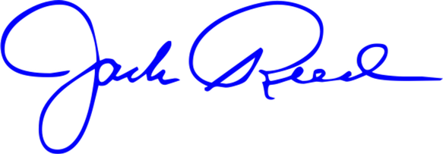
Jack Reed
United States Senator
Richard J. Durbin
United States Senator



Christopher A. Coons
United States Senator
Brian Schatz

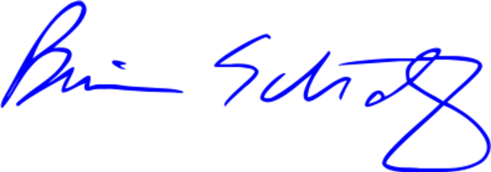
United States Senator


Christopher S. Murphy United States Senator
Chris Van Hollen United States Senator



Jeanne Shaheen
United States Senator
Jeffrey A. Merkley

United States Senator

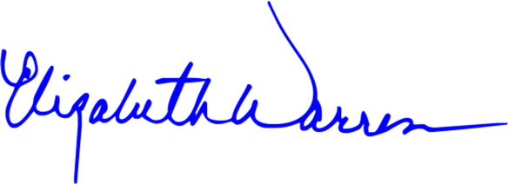
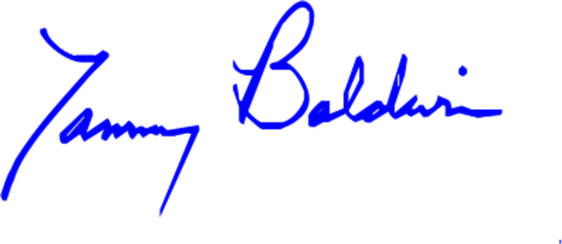
Elizabeth Warren United States Senator

Tammy Baldwin United States Senator



Mark R. Warner
United States Senator
Catherine Cortez Masto

United States Senator



Tina Smith
United States Senator
Raphael Warnock

United States Senator


Andy Kim
United States Senator
Ruben Gallego United States Senator




Lisa Blunt Rochester United States Senator
Angela Alsobrooks United States Senator



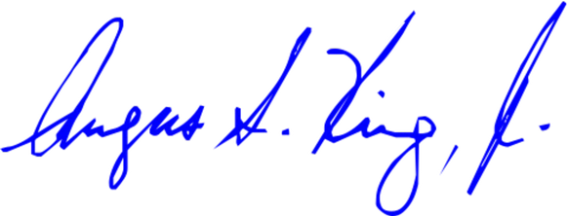
Angus S. King, Jr. United States Senator
Maria Cantwell United States Senator


Tim Kaine
United States Senator
Alex Padilla
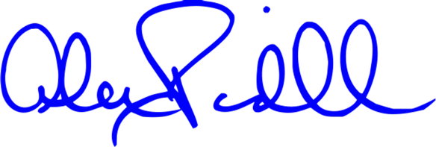
United States Senator



Sheldon Whitehouse
United States Senator
Richard Blumenthal

United States Senator



Adam B. Schiff United States Senator
Ron Wyden

United States Senator

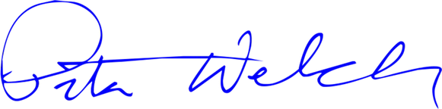
Peter Welch
United States Senator
Edward J. Markey United States Senator



Cory A. Booker
United States Senator
Margaret Wood Hassan
United States Senator



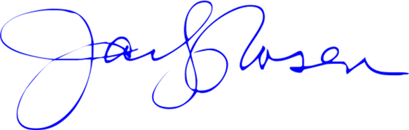
Jacky Rosen

United States Senator
Bernard Sanders United States Senator


Mazie K. Hirono United States Senator
Tammy Duckworth United States Senator

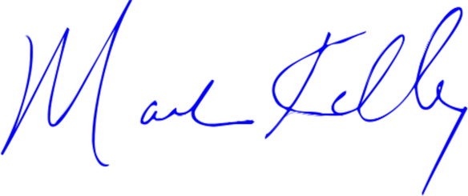
Mark Kelly
United States Senator
Amy Klobuchar United States Senator



Ben Ray Luján United States Senator

