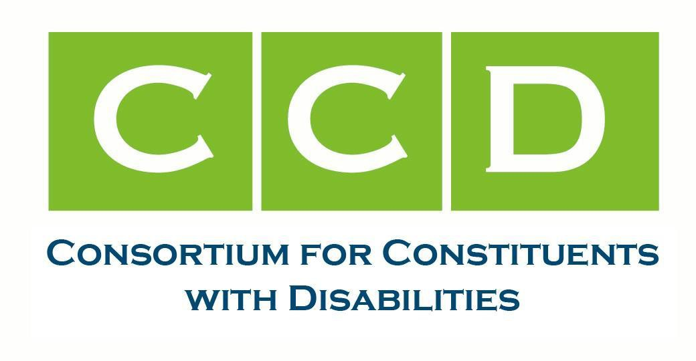
April 30, 2025,

The Honorable Susan Collins, Chair Committee on Appropriations Room S128, The Capitol Washington, D.C. 20510  The Honorable Tom Cole, Chairman House Committee on Appropriations H307, The Capitol  Washington, DC 20515 | The Honorable Patty Murray, Vice Chair Committee on Appropriations  Room S128, The Capitol Washington, D.C. 20510  The Honorable Rosa DeLauro, Ranking Member  House Committee on Appropriations H307, The Capitol  Washington, DC 20515

Re: FY2026 Appropriations for Critical Housing Programs for Adults with Disabilities Dear Sens. Collins and Murray, and Reps. Cole and DeLauro:
On behalf of the Consortium for Constituents with Disabilities CCD Housing Task Force, we write to urge your leadership to secure essential Fiscal Year FY 2026 funding for the U.S. Department of Housing and Urban Development HUD Section 811 and
Mainstream/Non-Elderly Disabled NED Voucher programs, as well as fair housing enforcement programs.
CCD is the largest coalition of national organizations working together to advocate for Federal public policy that ensures the self-determination, independence, empowerment, integration, and inclusion of children and adults with disabilities in all aspects of society. The CCD Housing Task Force focuses on ensuring accessible, affordable, and equitable housing is available for all people with disabilities in communities of their own choosing.
Housing remains a critical and urgent issue for the 71 million Americans with disabilities¹, many of whom are being left behind by current housing policies. Approximately 18 million adults with disabilities qualify for federal housing assistance but are not receiving it.² The stark reality is that over 3.9 million non-elderly adults with disabilities who rely on Supplemental Security Income SSI — with a maximum federal benefit rate of just $967 per month — cannot afford

¹ CDC Data Shows Over 70 Million U.S. Adults Reported Having a Disability
² People with Disabilities Living in the US Face Urgent Barriers to Housing | Urban Institute

housing in any U.S. rental market.³ Without appropriate intervention, millions are forced into institutional settings, homelessness, or unstable and inaccessible living arrangements⁴.
The HUD Section 811 and Mainstream/NED Voucher programs are key tools in addressing this crisis, offering integrated, affordable, accessible housing solutions. We respectfully request your support for the following FY26 appropriations and policy improvements:
Mainstream & Non-Elderly Disabled NED Housing Vouchers provide rental assistance to extremely low-income, non-elderly individuals with disabilities. While over 125,000 households have been helped through these programs, current funding reaches only a fraction 24% of those eligible.⁵
The FY26 budget requests include full funding for all Housing Choice Voucher renewals, including Mainstream and NED vouchers, and $500 million in new funding for an estimated 50,000 new Mainstream vouchers to expand access. We also request budget language provisions that would enhance program efficiency. The language request is that the regulatory and discretionary waivers under HUD PIH Notice 202430 be applied to NED Vouchers.
HUDʼs Section 811 Program is the only federal program solely dedicated to creating deeply affordable, accessible, and integrated housing for non-elderly disabled individuals. Section 811 PRA Project Rental Assistance) is delivered via state partnerships, but limitations persist—many states and territories remain unfunded, and awards are capped at $8 million per state. The FY26 budget requests include full funding for all renewals of Section 811 PRA and Project-Based Rental Assistance Contracts PRACs, and $424 million for new Section 811 PRA awards, with a minimum of $8 million allocated to every state and territory.
The following recommended language requests would also create greater utilization of the program: allow the use of PRA funds for access modifications, security deposits, damage coverage (up to twice the deposit), HUD system participation costs, and service coordination; expand eligibility to two-person households where both receive SSI and their combined income falls between 3050% of Area Median Income AMI; and direct HUD to incentivize integrated housing models in the allocation of PRAC funds.
We also request your support with vital funding for fair housing enforcement programs:
Fair housing enforcement ensures equitable access to housing for people with disabilities. The majority of fair housing complaints each year involve disability discrimination, and the number of fair housing complaints overall in recent years have reached record highs. More resources are needed to prevent and combat housing discrimination that contributes to housing insecurity, homelessness, and institutionalization for people with disabilities.
Our FY26 budget requests include $125 million for the Fair Housing Initiatives Program FHIP,
$36.6 million for the Fair Housing Assistance Program FHAP, and $153 million for HUDʼs Office of Fair Housing and Equal Opportunity FHEO.

³ Priced Out Report
⁴ Laying the Foundation: Housing Accessibility and Affordability for Older Adults and People with Disabilities
⁵ Special Purpose Voucher Programs for People With Disabilities: How They've Evolved, What We've Learned, and Where We

We believe these investments are a fiscally responsible approach that promotes independence, community inclusion, and long-term cost savings. We urge Congress to meet the scale of the need by ensuring that all funding for HUD housing programs – including HUD 811, Housing Choice Vouchers, and fair housing enforcement – is renewed, expanded, and modernized.
For further information, please contact CCD Housing Task Force co-chairs: Allie Cannington (allie@thekelsey.org), Gregory Robinson (grobinson@autisticadvocacy.org), and Jennifer Kye (jkye@justiceinaging.org).

Sincerely,
American Association of People with Disabilities American Association on Health and Disability Access Ready Inc.
Autistic Self Advocacy Network Autism Society of America
Autistic Women & Nonbinary Network Cure SMA
Justice in Aging Lakeshore Foundation
Muscular Dystrophy Association National PLAN Alliance NPA National Consumer Law Center National Womenʼs Law Center SAGE
The Arc of the United States The Kelsey
Epilepsy Foundation of America Cc:
The Honorable Senator Cindy Hyde-Smith, Chair
Subcommittee on Transportation, Housing & Urban Development Senate Appropriations Committee

The Honorable Senator Kirsten Gillibrand, Ranking Member Subcommittee on Transportation, Housing & Urban Development Senate Appropriations Committee

The Honorable Steve Womack, Chair
Subcommittee on Transportation, Housing & Urban Development House Committee on Appropriations

The Honorable James E. Clyburn, Ranking Member Subcommittee on Transportation, Housing & Urban Development House Committee on Appropriations

